ASSESSMENT GUIDELINES FOR GEOGRAPHY AT ADVANCED SECONDARY LEVEL

  - INTRODUCTION
Geography in the ASC is assessed at school and at the End of the Cycle examinations which is administered by the Uganda National Examinations Board (UNEB).
Assessment of Geography at school level will be formative and summative. Formative assessment will be done through observation (watching learners working), conversation (asking questions and talking to learners) and appraising the learners’ work (product). While summative assessment will be done through engaging learners in activities of integration at the end of each topic and an examination at the end of the year.
The end of cycle assessment for Geography for the Advanced Secondary Curriculum will be guided by assessment objectives based on the constructs. A construct is an abstract representation of a unifying theme that brings coherence to an assessment task. It serves as a generalised concept that combines a cluster of related learning outcomes or competencies—each contributing to a common learning ability. Acquisition of learning outcomes/ competencies in a construct enables the learner to demonstrate mastery in a way that supports real-life functionality and application.

  - ASSESSMENT OBJECTIVES
The end of Cycle assessment for Geography will be guided by four assessment objectives focusing on the learner’s ability to:

AO1: Apply knowledge of geomorphic processes, geographic tools and techniques to assess development opportunities and address challenges in a given area.

AO2: Devise innovative ways of responding to challenges resulting from extreme weather events, climate variability and climate change through applying knowledge of atmospheric processes, geographic tools and techniques.

AO3: Design effective plans for promoting development in specific places by analysing development patterns, population, settlement and production systems using geographic tools and techniques.

AO4: Devise innovative strategies for sustainable utilisation of natural resources based on the context, using geographical tools and techniques.

1.3 LINKAGE BETWEEN ASSESSMENT OBJECTIVES, CONSTRUCTS AND SYLLABUS
The table below shows a linkage between the assessment objectives, the constructs and the topics that contribute to the construct.

Table 1: Table showing relationship between assessment objectives, constructs and the topics in the syllabus
Assessment Objective | Construct | Construct Description | Topics in the syllabus
AO1: Apply knowledge of geomorphic processes, geographic tools and techniques to assess development opportunities and address challenges in a given area. | Geomorphic processes and their impacts | Analysing the Earth, geomorphic processes and the influence these processes have on human activities using geographic tools and techniques; and proposing feasible ways of coping with, mitigating and adapting to the effects of such processes | 1. The Structure of the Earth  2. The Origin of Continents and Ocean Basins  7. Drainage and the Role of Rivers in Shaping the Landscape  11. Slope Development  13. Lake and Sea Coasts
AO2: Devise innovative ways of responding to challenges resulting from extreme weather events, climate variability and climate change through applying knowledge of atmospheric processes, geographic tools and techniques. | Weather and Climate Systems | Analysing the atmosphere, atmospheric processes and their effects on physical and human environments using a range of geographic tools, techniques, and knowledge to predict short- or long-term weather patterns for places at different scales so as to propose innovative ways of mitigating and adapting to challenges resulting from extreme weather events, climate variability and climate change | 9. Climatology and Meteorology
AO3: Design effective plans for promoting development in specific places by analysing development patterns, population, settlement and production systems using geographic tools and techniques. | Human – Environment Interaction | Evaluating development, settlement and production systems at different scales using geographic tools, techniques and relevant knowledge to design effective plans and ways of promoting balanced interaction between people and the environment | 3. World Development  4. Agriculture and Development  6. Population and Development  10. Settlement and Urban Growth  12. Problems of Food Supply
AO4: Devise innovative strategies for sustainable utilisation of natural resources based on the context, using geographical tools and techniques. | Sustainable Use of natural Resources | Designing context-specific and innovative strategies for sustainable utilisation of natural resources, and promotion of environmental stewardship; applying a range of geographical tools and techniques. | 5. Soil Development  and Management  8. Energy Production  14. Utilisation and Conservation of Natural Resources

2.0 TABLE OF CONSTRUCTS

The table below details the constructs for Geography, i.e. the competencies / learning outcomes that make up the construct, the expected learner abilities and what the assessor should look out for in the learner’s work as evidence of achievement of the intended learning outcomes (indicators of mastery).

Construct | Learning Outcomes  The learner should be able to: | Abilities | Indicators of Masterly | Level of Complexity
1.Geomorphic processes and their impacts  Analysing the Earth, geomorphic processes and the influence these processes have on human activities using geographic tools and techniques; and proposes feasible ways of coping with, mitigating and adapting to the effects of such processes | 1(a) Analyse the Earth by examining its nature, shape, and external features as a basis for exploring its internal structure (u, gs). | - Examine the nature/ shape/ and external features of the Earth  - Illustrate the shape and external structure of the Earth  - Explain ideas clearly | - Examines the nature/ shape/ and external features of the Earth  - Draws diagrams to illustrate the shape and external structure of the Earth  - Presents ideas clearly and in detail | HIGH
 | 1(b) Assess the significance of the internal properties of the Earth in understanding the evolution of tectonic landforms and some natural resources (k, u, gs, v/a). | - Explain the internal structure of the Earth and their properties  - Analyse the relationship between the interior of the Earth, landforms and natural resources  - Draw diagrams to illustrate the internal structure of the Earth and endogenic geomorphic processes  - Form opinions/make judgment/draw conclusions about the importance of the internal layers of the Earth and their properties in the formation of landforms and natural resources  - Sort and analyse information  - Use a range of media to communicate ideas | - Explains the internal structure of the Earth and their properties  - Analyses the relationship between the interior of the Earth, landforms and natural resources  - Draws diagrams to illustrate the internal structure of the Earth and endogenic geomorphic processes  - Gives opinions/make judgment/draws conclusions about the importance of the internal layers of the Earth and their properties in the formation of landforms and natural resources | HIGH
 | 2(a) Evaluate the continental drift theory using scientific evidence (u, v/a). | - Use palaeographic and modern maps to find out about the origins of continents and ocean basins  - Discuss the available pieces of evidence of continental drift  - Evaluate information  - Plan and carry out investigations | - Interprets palaeographic and modern maps; and communicates information about them  - Weighs the available pieces of evidence of continental drift  - Expresses own opinions /makes judgment about the continental drift theory | HIGH
 | 2(b) Predict the future shapes, sizes and positions of world continents and landforms basing on the knowledge of the continental drift theory (u, s, v/a). | - Analyse the movement of world continents and their effects on continental land masses, ocean basins, seas, relief and landforms  - Explain the likely effects of continental drift on the future shapes and sizes of present-day continental land masses  - Analyse existing information: photographs and texts  - Look for patterns and make generalisations  - Draw diagrams/models to illustrate the likely effects of continental drift on the future shapes, sizes and positions of world continents and landforms | - Examines the movement of world continents and their effects on continental land masses, ocean basins, seas, relief and landforms  - Explains the likely effects of continental drift on the future shapes and sizes of present-day continental land masses  - Draws meanings and conclusions from photographs and texts  - Draws diagrams/models to illustrate the effects of continental drift on the future shapes, sizes and positions of world continents and landforms | HIGH
 | 2(c) Demonstrate appreciation of the role of scientific inquiry in understanding geomorphic processes and their influence on the way we live on earth (u, gs, v/a). | - Evaluate the importance of theories in driving geomorphic investigations  - Assess the influence of geomorphic processes on people’s ways of life | - Examines the importance of theories in driving geomorphic investigations  - Gives own opinions about the importance of using theories in geomorphic investigations  - Examines the relationship between continental drift, geomorphic processes and people’s ways of life | HIGH
 | 11(a) Assess the influence of slope development on the physical environment and human activities (u). | - Assess the applicability of theories of slope development (Lester C. King, Penck and William Davis) to observable slope processes and landscape.  - Draw diagrams to illustrate slope development processes  - Analyse the influence of slope development on the physical environment and human activities  - Analyse and interpret photographs/ topographic survey maps  - Sort and analyse information | - Applies theories of slope development (Lester C. King, Penck and William Davis) to analyse observable slope processes and landscape.  - Cites examples of areas where theories of slope development apply  - Draws diagrams to illustrate slope development  - Examines the influence of slope development on the physical environment and human activities  - Derives meanings and conclusions from photographs/ topographic survey maps depicting slope development and its influence on the physical environment and human activities | HIGH
 | 11(b) Appraise programs and actions aimed at mitigating and responding to occurrence of mass wasting in the highland areas of Uganda and the rest of East Africa (u, v/a). | - Analyse qualitative and quantitative information on mass wasting  - Analyse and interpret photographs depicting mass wasting and its effects  - Draw maps to show areas where mass wasting occurs  - Draw diagrams to illustrate types and processes of mass wasting  - Evaluate programs and actions aimed at responding to mass wasting in a given highland area  - Sort and analyse information and offer solutions | - Derives meaning and conclusions from qualitative and quantitative information on mass wasting  - Derives meaning and conclusions from photographs depicting mass wasting and its effects  - Draws maps to show areas where mass wasting occurs  - Draws diagrams to illustrate types and processes of mass wasting  - Assesses the effectiveness of programs and actions aimed at responding to mass wasting in a given highland area  - Gives own opinions about programs and actions aimed at mitigating and responding to mass wasting in a given area  - Recommends environmentally friendly actions that can mitigate mass wasting based on available data | HIGH
 | 11(c) Predict the occurrence of mass wasting in highland areas by analysing and applying the relevant geographical information (v/a). | - Gather and analyse qualitative information about Indicators of the possibility of occurrence of mass wasting  - Analyse and interpret modelled data  - Evaluate different solutions | - Collects field information about mass wasting  - Uses information from various data sources to predict the occurrence of mass wasting | HIGH
 | 11(d) Propose strategies for preventing mass wasting in the highland areas of Uganda by applying relevant information (v/a). | - Analyse qualitative data  - Analyse and interpret topographic survey maps  - Suggest strategies for preventing mass wasting in highland areas  - Identify problems and propose solutions  - Use a range of media to communicate ideas | - Draws meanings and conclusions from qualitative data about mass wasting  - Draws meanings and conclusions from topographic survey maps taken from highland areas  - Recommends environmentally friendly strategies for preventing mass wasting in highland areas  - Draws diagrams to illustrate proposed solutions to mass wasting | HIGH
 | 7(a) Demonstrate an understanding of Uganda’s drainage system by using relevant maps and diagrams to illustrate its aspects (u, s). | - Draw maps to illustrate Uganda’s drainage system  - Draw diagrams to illustrate aspects of Uganda’s  - Describe the drainage system of Uganda  - Use topographic survey maps to find out about drainage  - Explain ideas clearly  - Sort and analyse information | - Draws maps to illustrate drainage system of Uganda  - Draws diagrams to illustrate aspects of Uganda’s features, patterns, and their interrelationships  - Describes the features, patterns, interrelationships of Uganda’s drainage  - Derives meanings and conclusions about drainage from topographic survey maps | MEDIUM
 | 7(b) Assess the role of Pleistocene Earth movements in the evolution of Uganda’s drainage and resources (v/a). | - Assess the Influence of Pleistocene Earth movements on the evolution of Uganda’s drainage  - Assess the Influence of Pleistocene Earth movements on Uganda’s resources  - Draw maps and diagrams to illustrate the evolution of Uganda’s drainage  - Use a range of media to communicate ideas | - Examines the Influence of Pleistocene Earth movements on the evolution of Uganda’s drainage  - Discusses the contribution of Pleistocene Earth movements to evolution of Uganda’s resources  - Draws maps /diagrams to illustrate Uganda’s drainage system | HIGH
 | 7(c) Infer, from photographs, topographic survey maps and field observations the river channel processes taking place in an area (s). | - Analyse and interpret photographs and topographic survey maps showing river valleys  - Sort and analyse information  - Gather and interpret information from the field about river channel processes  - Draw river channel profiles and associated landforms | - Draws meanings and conclusions about river channel processes from photographs and topographic survey maps  - Deduces river channel processes from field observations of a river channel  - Explains river channel processes  - Illustrates river channel profiles and associated landforms | HIGH
 | 7(d) Develops a plan for exploiting the resource potential presented by a drainage feature or features to improve peoples’ lives by applying relevant knowledge and skills (u, s, gs, v/a). | - Suggest plans for utilising resources associated with certain drainage feature or features  - Identify problems and propose solutions  - Explain ideas/ opinions clearly | - Proposes feasible plans for utilising resources associated with certain drainage feature or features potential  - Recommends environmentally friendly ways of utilising certain drainage feature or features to improve people’s lives  - Explains ideas clearly and in detail | HIGH
 | 13(a) Analyse the formation and characteristics of coastal landforms and evaluate their significance in shaping coastal landscapes over time (u). | - Explain the formation of landforms at lake or sea coasts  - Describe landforms at the coast  - Draw diagrams to illustrate coastal processes and resultant landforms  - Analyse and interpret topographic survey maps and photographs taken from coastal areas  - Examine the importance of coastal landforms in shaping the human landscape  - Sort and analyse information | - Explains the formation of landforms at lake or sea coasts  - Describes landforms at the coast  - Draws diagrams to illustrate coastal processes and resultant landforms  - Draws meanings and conclusions from maps and photographs taken from coastal areas  - Examines the importance of coastal landforms in shaping the human landscape | HIGH
 | 13(b) Predict the future relationship between land and sea or lake coast, using knowledge of current crustal stability and ongoing climate change, to raise awareness about natural hazards affecting coastal areas (v/a). | - Analyse qualitative and quantitative information about the relationship between land and sea or lake  - Analyse and interpret topographic survey maps and photographs from coastal areas  - Demonstrate an understanding of lake/sea level changes  - Analyse natural hazards associated with lake/sea level changes in coastal areas  - Sort and analyse information | - Draws meanings and conclusions from qualitative and quantitative data about the relationship between land and the sea or lake  - Derives meaning and conclusions from topographic survey maps and photographs from coastal areas  - Explains the concept of lake/sea level changes  - Examines the natural hazards associated with lake/sea level changes in coastal areas  Cites examples of natural hazards associated with lake/sea level changes in coastal areas | HIGH
 | 13(c) Analyse the resource potential associated with coastal landforms and how this can be tapped for development (v/a). | - Analyse qualitative information about coastal areas  - Analyse and interpret photographs taken from coastal areas | - Discusses the possible benefits of coastal landforms  - Derives meaning and conclusions from photographs about resource potential associated with coastal landforms | HIGH
 | 13(d) Propose a plan for developing a coast based on its actual and potential resources and challenges as a way of facilitating resource utilisation and community development (s, gs). | - Analysing qualitative information about coastal areas  - Analyse and interpret photographs from coastal areas  - Analyse challenges affecting utilisation of resources in coastal areas  - Suggest and develop new solutions  - Predict outcomes and make reasoned decisions | - Derives meanings and conclusions from qualitative information taken from coastal areas  - Derives meanings and conclusions about actual and potential resources of coastal areas from photographs  - Analyses challenges affecting utilisation of resources in a certain coastal area  - Devises a plan for developing a coastal area based on its resources and current challenges | HIGH
2. Weather and Climate Systems  Analysing the atmosphere, atmospheric processes and their effects using a range of geographic tools, techniques, and knowledge to predict short- or long-term weather patterns for places at different scales so as to propose innovative ways of mitigating and adapting to climate variability and change | 9(a) Analyse the atmosphere and its influence on weather, climate and life on earth through examining its layers and composition (u, s, gs). | - Analyse qualitative and quantitative information about the structure and composition of the atmosphere  - Draw diagrams to illustrate layers of the atmosphere  - Draw diagrams to illustrate temperature variation in the atmosphere  - Analyses the relationship between the layers and composition of the atmosphere; and weather, climate and life on Earth  - Sort and analyse information | - Describes layers of the atmosphere and composition of the atmosphere  - Draws diagrams to illustrate layers of the atmosphere  - Draws diagrams to illustrate temperature variation in the atmosphere  - Examines the relationship between the layers and composition of the atmosphere, weather, climate and life on Earth | HIGH
 | 9(b) Demonstrate an understanding of solar radiation by analysing its nature, interaction with the atmosphere, and effects on weather, climate, and life on Earth (u, gs, v/a). | - Analyse qualitative and quantitative information relating to solar radiation  - Analyse the nature and characteristics of solar radiation  - Draw diagrams to illustrate the journey of solar radiation through the atmosphere (solar cascade)  - Analyse the effects of the atmosphere and the earth’s surface on solar radiation  - Explain the influence of solar radiation on weather, climate and life on Earth  - Sort and analyse information | - Interprets quantitative or qualitative data relating to solar radiation  - Examines the nature and characteristics of solar radiation  - Draws diagrams to show the journey of solar radiation (solar cascade)  - Examines the effects of the atmosphere and the earth’s surface on solar radiation  - Explains the influence of solar radiation on weather, climate and life on Earth | HIGH
 | 9(c) Discuss factors influencing the amount of solar radiation received at given place and appreciate temperature variations and their effects on life (u, v/a) | - Explain the factors influencing the amount of solar radiation received at given place  - Draw diagrams to illustrate the factors influencing the amount of solar radiation received at a given place  - Examine the relationship between solar radiation and temperature  - Examine the effects of variations in insolation on human activities and ecosystems in certain areas  - Sort and analyse information | - Explains the factors influencing the amount of solar radiation received at a given place  - Draws diagrams to illustrate the factors influencing the amount of solar radiation received at a given location  - Explains the relationship between solar radiation and temperature  - Discusses the effects of variations in insolation on human activities and ecosystems in certain areas | HIGH
 | 9(a2) Analyse the causes, effects and implications of temperature inversion on local weather patterns, air quality, and climate systems (u, v/a). | - Investigate the types, causes and effects of temperature inversion  - Draw diagrams to illustrate temperature inversion  - Analyse maps and photographs depicting the effects of temperature inversion on other atmospheric conditions  - Write and present information coherently | - Analyses the types, causes; and effects of temperature inversion on local weather patterns, air quality, and human activities  - Draws diagrams to illustrate temperature inversion  - Derives meanings and conclusions from photographs depicting the effects of temperature inversion  - Clearly and logically communicates ideas relating to temperature inversion | HIGH
 | 9(a3) Demonstrate an understanding of the relationship between humidity and other weather conditions to appreciate the role of humidity in regulating temperature and maintaining life on Earth (u, v/a). | - Analyse qualitative and quantitative data about humidity and other elements of weather  - Explain factors Influencing humidity at a given place  - Analyse the influence of humidity on weather patterns, ecosystems and human life  - Sort and analyse information | - Examines the relationship between humidity and other elements of weather based on data  - Explains factors Influencing humidity at a given place  - Assesses the significance of humidity in maintaining life  - Examines the influence of humidity on weather patterns, ecosystems and human lives | HIGH
 | 9(b2) Predict the occurrence and intensity of precipitation using the knowledge of humidity (s, gs, v/a). | - Analyse weather maps to describe humidity levels and trends  - Predict the occurrence of precipitation using relevant data and knowledge of humidity  - Use numbers and measurements accurately | - Describes humidity levels and trends from weather maps  - Predicts the occurrence of precipitation based on relevant data and knowledge of humidity  - Explains the role of humidity in precipitation formation.  - Determines relative humidity based on data | HIGH
 | 9(c2) Analyse the relationship between temperature, atmospheric pressure, and wind movement using appropriate illustrations (u, a/v). | - Analyse weather charts to determine temperature, pressure and wind patterns  - Read and interpret weather maps  - Draw maps and diagrams to illustrate atmospheric pressure belts  - Sort and analyse information | - Compares temperature, pressure and wind patterns using information from weather charts  - Derives meaning and conclusions from information presented on weather maps  - Explains how temperature affects pressure and wind movement.  - illustrates different wind systems and their causes using diagrams or charts.  - Draws well-labelled diagrams to illustrate weather patterns. | HIGH
 | 9(d) Demonstrate an understanding of winds at different scales by examining their types, causes, and effects on weather, climate, and people’s ways of life (u). | - Explain types and characteristics of local and planetary winds  - Draw maps and diagrams to illustrate local and global winds  - Explain causes of winds  - Analyse the effects of winds on weather, climate, human activities and peoples’ ways of life  - Analyse qualitative and quantitative information about winds  - Look for patterns and make generalisations | - Explains types and characteristics of local and planetary winds  - Draws maps and diagrams to illustrate local and global winds  - Explains causes of winds  - Examines the effects of winds on weather and climate; and their influence on human activities and ways of life  - Recommends ways of managing the effects of winds  Derives meanings from qualitative and quantitative information relating to winds recorded at different scales | MEDIUM
 | 9(e) Predict weather conditions and their effect at a given place through interpreting weather maps and satellite images (u, s). | - Use information on weather maps and satellite images to predict short term weather conditions  - Analyse and interpret weather maps and satellite images  - Predict outcomes and make reasoned decisions  - Look for patterns and make generalisations | - Uses information on weather maps and satellite images to predict short term weather conditions for a given place  - Predicts the likely effects of forecast weather conditions and their effect at a given place based on interpretation of weather maps and satellite images | HIGH
 | 9(f) Articulate the role of ocean currents in distributing heat across low and high latitudes using relevant knowledge (v/a). | - Draw maps and diagrams to illustrate different Ocean Currents  - Describe the causes, types and characteristics of different ocean currents  - Explain the impact of ocean currents on weather and climate  - Look for patterns and make generalisations | - Draws maps and diagrams to illustrate different ocean currents  - Describes the causes, types and characteristics of different ocean currents  - Explains the impact of ocean currents on weather and climate | LOW
 | 9(g) Form opinions about the effects of ocean currents on the climate of coastal areas, adjacent landmasses and human activities. (v/a) | - Analyse the effects of ocean currents on the climate of coastal areas, adjacent landmasses and human activities.  - Form opinions about the effects of ocean currents on the climate of coastal areas, adjacent landmasses and human activities  - Sort and analyse information  - Look for patterns and make generalisations | Examines the effects of ocean currents on the climate of coastal areas, adjacent landmasses and human activities.  - Gives own opinions about the effects of ocean currents on the climate of coastal areas, adjacent landmasses and human activities | HIGH
 | 9(h) Analyse climatic changes through time and at different scales to appreciate the origin and nature of the ongoing climate change (v/a). | - Analyse data on climate change  - Draw diagrams to illustrate the Greenhouse effect  - Gather qualitative and quantitative data about climate change  - Plan and carry out investigations  - Use a range of media to communicate ideas | - Derives meanings and conclusions from climate data  - Draws diagrams to illustrate the Greenhouse effect  - Gathers qualitative and quantitative data about climate change  - Communicates information about climate change using different media | HIGH
 | 9(i) Assess the contribution of natural processes and human activities to climate change by analysing statistics and other relevant information (u, v/a). | - Weigh the significance of natural and human causes of climate change  - Form opinions about the significance of natural and human causes of climate change  - Draw statistical graphs and diagrams to illustrate aspects of climate change  - Gather qualitative and quantitative data about causes of climate change  - Look for patterns and make generalisations  - Use a range of media to communicate ideas about climate change | - Compares the contribution of natural and human factors to climate change  - Gives own opinions about the significance of natural and human causes of climate change  - Draws statistical graphs and diagrams to illustrate aspects of climate change  - Gathers qualitative and quantitative data about causes of climate change | HIGH
 | 9(j) Demonstrate understanding of the effects of climate change by examining its impact on certain sectors and ecosystems (k, u, v/a) | - Analyse the effects of climate change on certain sectors and/or ecosystems  - Analyse qualitative and quantitative information about the effects of climate change  - Gather qualitative and quantitative data about effects of climate change  - Plan and carry out investigations | - Examines the effects of climate change on certain sectors and/or ecosystems  - Derives meanings and conclusions from information and/or data about effects of climate change  - Gathers qualitative and quantitative data about the effects of climate change in a given area | HIGH
 | 9(k) Develop an action plan or manifesto to address climate change and its effects in a certain locality (u, s, gs, v/a). | - Gather qualitative and quantitative data on climate change and its effects in a certain locality.  - Analyse qualitative and quantitative information about climate change and its effects  - Identify problems and suggest ways forward  - Sort and analyse information | - Gathers qualitative and qualitative data such as “documents data on climate change and its effects in a given locality  - Uses statistical graphs and diagrams to analyse the effects of climate change in a given locality  - Designs a context - specific action plan or manifesto to address effects of climate change. | HIGH
3. Human – Environment Interaction  Evaluating development, settlement and production systems at different scales using geographic tools, techniques and relevant knowledge to design effective plans and ways of promoting balanced interaction between people and the environment | 3(a) Form opinions about the world development pattern through analysing statistics, maps, and other relevant information (s, gs, v/a). | - Describe the pattern of world development  - Analyse statistical data, graphs, diagrams and maps about world development  - Form opinions about world development pattern; and the development of Uganda  - Sort and analyse information | - Describes the pattern of world development  - Draws charts/ graphs/diagrams to illustrate statistical data relating to world development  - Derives meaning from qualitative and quantitative information/data relating to world development.  - Gives own opinions about world development pattern; and the level of development in Uganda | HIGH
 | 3(b) Analyse the level of development in the local area and home country by applying various indicators used to measure development to appreciate community and government efforts to improve the lives of the people (s, gs, v/a). | - Collect and communicate data about development in a certain area  - Determine the level of development in a given area/ Uganda  - Evaluate community and government efforts to promote development in a given area/Uganda  - Accounts for the variations in development in the local area/Uganda  - Interpreting and interrogating mathematical data  - Use a range of media to communicate ideas | - Collects quantitative and qualitative data about development about a certain area  - Uses a range of methods to communicate data about development in a certain area  - Applies indicators of development to determine the level of development in a given area/Uganda  - Assesses the effectiveness of community and government efforts to promote development in a given area/Uganda  - Gives own opinions about community and government efforts to improve the lives of people in a given area/Uganda  - Explains reasons accountable for variations in development in the local area | HIGH
 | 3(c) Predict the future trend of development in Uganda and other countries using relevant information (gs, v/a). | - Analyse data and information about the current level of development of Uganda/other countries to predict future development trends  - Interpreting and interrogating mathematical data  - Analyse situations  - Look for patterns and make generalisations | - Derives meaning and conclusions from data/information relating to the current level of development of Uganda/other countries  - Predicts future development trends for Uganda or other countries based on available data and information  - Relates current and future development levels of a country | HIGH
 | 3(d) Analyse the conditions which may slow down or totally affect holistic regional or national development as a basis for planning proper management and utilisation of resources (u, v/a). | - Analyse spatial development disparities at different scales; their causes and effects  - Analyse factors which can affect development  - Suggests ways to promote proper management and utilisation of resources for development  - Suggest and develop new solutions | - Compares and contrasts development for different countries, regions and continents  - Analyses factors responsible for development disparities within countries; and between countries and regions  - Proposes feasible ways of utilising natural and human resources to promote development | HIGH
 | 3(e) Propose a suitable development strategy for Uganda through applying the knowledge of sustainable development models (u, gs, v/a). | - Defend the rationale for promoting sustainable development in Uganda  - Propose measures which can be taken to achieve sustainable development in Uganda  - Choose/design/adapt a context-specific development model  - Use imagination to explore possibilities | - Argues out a case for promoting sustainable development in Uganda  - Proposes measures which can be taken to achieve sustainable development in Uganda  - Chooses/designs/adapts a model or plan to promote sustainable development in the local area or Uganda | HIGH
 | 4(a) Evaluate plans and strategies aimed at promoting agriculture in Uganda and other developing countries (s, gs, v/a). | - Discuss the role of agriculture in Uganda  - Analyse the challenges facing the development of agriculture in Uganda  - Assess the effectiveness of plans and strategies put in place to at promote agriculture in Uganda or other countries.  - Forms opinions about plans and strategies put in place to at promote agriculture in Uganda or other countries. | - Discusses the role of agriculture in Uganda  - Analyses the challenges facing the development of agriculture in Uganda  - Assesses the effectiveness of strategies and plans aimed at promoting agriculture in Uganda or other countries.  - Gives own opinions about plans and strategies put in place to at promote agriculture in Uganda or other countries. | HIGH
 | 4(b) Demonstrate an understanding of subsistence farming by articulating its types, characteristics and challenges affecting it (u, s, gs). | - Carryout investigations and report about subsistence farming and its challenges in a given area or country  - Explain the types and characteristics of subsistence farming  - Analyse the challenges affecting subsistence farming  - Plan and carry out investigations | - Investigates and communicates information about subsistence farming and its challenges in a given area or country  - Explains the types and characteristics of subsistence farming  - Examines the challenges affecting subsistence farming. | HIGH
 | 4(c) Evaluate policies and strategies aimed at improving subsistence agriculture in Uganda and other countries in order to select the most feasible options for addressing the challenges faced by farmers (u, s, gs, v/a). | - Analyse policies and strategies aimed at improving subsistence agriculture in Uganda and other countries  - Assess the effectiveness of strategies and policies aimed at improving subsistence agriculture in Uganda/other countries.  - Cite examples of success stories or/and failure of strategies and policies aimed at improving subsistence agriculture in Uganda/ other countries  - Forms opinions about strategies and policies put in place by Uganda/other countries to improve subsistence agriculture.  - Suggest possible better options for addressing the challenges faced by farmers in Uganda and other countries  - Identifying problems and proposing solutions  - Content analysis | - Derives meaning and conclusions from policies and strategies aimed at improving subsistence agriculture in Uganda and other countries  - Assesses the effectiveness of strategies and policies put in place to improve subsistence agriculture in Uganda/other countries.  - Cites examples to illustrate the success or/and failure of strategies and policies aimed at improving subsistence agriculture in Uganda/other countries.  - Gives own opinions about strategies and policies put in place by Uganda/other countries to improve subsistence agriculture.  - Proposes feasible and better ways of addressing challenges faced by farmers Uganda and other countries | HIGH
 | 4(d) Propose a suitable type of commercial agriculture to be adopted in a given locality based on the prevailing conditions to promote societal transformation (u, gs, v/a). | - Investigate the types and status of agriculture in a given locality  - Use photographs, topographic survey maps and other sources of information to evaluate the prevailing physical and socio-economic conditions in a given agricultural area  - Evaluate the feasibility (possibility) of carrying out certain types of commercial agriculture in a given area  - Choose and recommend a suitable type of commercial agriculture for a given area  - Give justification for the choice of type of commercial agriculture recommended for a given area  - Evaluating different solutions | - Describes the types and status of agriculture in a given area  - Determines the prevailing physical and socio-economic conditions in a given agricultural area based on information from photographs, topographic survey maps and other sources  - Evaluates the feasibility (possibility) of carrying out certain types of commercial agriculture in a given area  - Chooses and recommends a suitable type of commercial agriculture for a given area  - Defends the choice of type of commercial agriculture recommended for a given area | HIGH
 | 4(e) Evaluate programmes and policies aimed at modernising agriculture in Uganda and other countries to make informed decisions about transforming farming communities (v/a). | - Explain the steps, resources and stakeholders needed in modernising agriculture  - Evaluate programmes and policies aimed at modernising agriculture  - Analyse and interpret data about agricultural modernisation to predict outcomes  - Use a range of media to communicate ideas | - Explains the steps, resources, and stakeholders needed to modernise agriculture  - Assesses the effectiveness of policies and programmes aimed at modernising agriculture in Uganda and other countries  - Derives meanings and conclusions from data about agricultural modernisation  - Suggests feasible interventions for transforming agricultural communities in a given country based on the performance of earlier efforts. | HIGH
 | 4(f) Form opinions about the adoption of western-type farming techniques to improve agricultural productivity in Uganda and other developing countries (v/a). | - Analyse photographs, statistical data and statistical drawings portraying scenes and trends of agricultural modernisation in developed and developing countries  - Draw lessons from case studies to appraise different approaches to modernising agriculture  - Evaluates possibilities of adopting western-type farming techniques to improve agricultural productivity in developing countries  - Form opinions about the adoption of western-type farming techniques in developing countries  - Evaluate different solutions | - Derive meaning and conclusions from photographs, statistical data and statistical drawings portraying scenes and trends of agricultural modernisation in developed and developing countries  - Draws statistical diagrams to represent data concerning agricultural productivity  - Uses lessons from case studies to argue for or against the adoption of western-type farming techniques to improve agricultural productivity in Uganda/ other developing countries  - Gives own opinions about the adoption of western-type farming techniques in developing countries | HIGH
 | 6(a) Investigate the distribution and density of population using topographic maps, statistical data, and maps to guide decision-making(s). | - Investigate population distribution and density in certain areas  - Analyse qualitative and quantitative data about population distribution and density  - Draw statistical maps and diagrams to show population density and distribution  - Sort and analyse information | - Accounts for population distribution and density in certain areas  - Explains population distribution/density in a given area using information on photographs, topographic survey maps, statistical data, and statistical maps  - Draws statistical maps and diagrams to illustrate population density and distribution. | MEDIUM
 | 6(b) Propose ways of regulating population growth in developed and developing countries based on statistics and other relevant knowledge (u, s, gs). | - Analyse trends of and factors influencing population growth in certain areas  - Analyse and interpret qualitative and quantitative information on population growth in certain areas  - Draw statistical diagrams and maps to illustrate Population growth in certain areas  - Evaluate measure for controlling population growth in developed and developing countries  - Evaluate different solutions  - Identify problems and ways forward | - Discusses trends of and factors influencing population growth in certain areas  - Derives meanings and conclusions about population growth in certain areas  from qualitative and quantitative information  - Draws statistical diagrams and maps to illustrate Population growth in certain areas  - Proposes feasible ways of regulating population growth in certain countries  - Provides Justification for the choice of measures proposed to regulate population growth in certain countries | HIGH
 | 6(c) Infer the likely impact of population structure of a town/country or region on resource utilisation and people’s wellbeing to suggest ways of managing the population. (v/a) | - Analyse statistical data and population pyramids of a certain countries/areas  - Draw population pyramids to illustrate population structure of certain countries/areas  - Compare population structures of different countries/areas  - Assess the likely impact of population structure on resource utilisation and people’s wellbeing in certain countries/areas  - Suggest practical solutions to problems/challenges posed by a certain population structure  - Respect for humanity and the environment | - Draws meanings and conclusions from statistics and population pyramids of certain countries/areas  - Draws population pyramids from statistics to show population structure of certain countries/areas  - Compares population structures of different countries/areas  - Assesses the likely impacts of population structure on resource utilisation and people’s wellbeing in certain countries/areas  - Suggests practical solutions to problems/challenges posed by a certain population structure  - Recommends ways of managing populations that preserve human dignity. | HIGH
 | 6(d) Predict occurrence and impact of population migration in Uganda and other places based on the knowledge of migrations (c). | - Analyse qualitative and quantitative data on types and patterns of population migration  - Look for patterns and make generalisation about causes and effects of population migration  - Predict outcomes and make reasoned decisions using a range of data sources  - Use a range of media to communicate ideas about population migration | - Derives meanings and conclusions from data about population migration  - Derives meaning from graphs and other statistical representations of population migration.  - Plots flow maps and other statistical drawings to analyse population migration  - Predicts the possibility of occurrence, and likely impact of a certain type of migration relevant knowledge | HIGH
 | 6(e) Develop a plan/manifesto for regulating or promoting a certain type of population migration by applying relevant information (c). | - Investigate population migration in a certain area/country  - Devise a plan for regulating or promoting a certain type of population migration based on its merits or demerits  - Identifies problems and proposes solutions  - Respect for humanity | - Draws meanings and conclusions from data on population migration in a certain area/country  - Devises a plan for regulating or promoting a certain type of population migration based on its merits or demerits  - Argues out a case for regulating or promoting population migration in a manner that preserves human dignity. | HIGH
 | 10(a) Demonstrate an understanding of settlements by examining their types, characteristics, and patterns (u, s, v/a). | - Describe the types, characteristics and patterns of settlement in certain areas  - Analyse topographic survey maps and photographs to identify types, characteristics and patterns of settlement  - Sort and analyse information about settlement  - Use diagrams and maps to illustrate types, characteristics and patterns of settlement | - Describes the types, characteristics and patterns of settlement in certain areas  - Derives meanings and conclusions about settlement from topographic survey maps and photographs  - Uses diagrams and maps to illustrate types, characteristics and patterns of settlement | MEDIUM
 | 10(b) Analyse the relationship between settlement and the environment in regions with contrasting physical environments (u, v/a). | - Interpret topographic survey maps and photographs to relationship between settlement in different physical environments  - Analyse the factors influencing human settlement  - Explain challenges faced by human settlement in different environments  - Analyse how humans adapt to the challenges of different environments  - Appreciate cultural diversity depicted in settlement patterns | - Derives meanings and conclusions about settlement in contrasting physical environments based on information on topographic survey maps and photographs  - Examines the influence of physical factors and human on human settlement  - Explains challenges faced by human settlement in different environments  - Examines how human settlements adapt to the challenges in different physical environments. | HIGH
 | 10(c) Analyse the changing types, patterns and functions of rural settlements in Uganda and other countries and the impacts these have on the surrounding areas (v/a). | - Investigate sites and location of rural settlements  - Explain the impact of rural settlement on both natural and human environments  - Plan and carry out investigations; identify problems and propose solutions  - Suggests measures to mitigate negative impacts of rural settlement  - Analyse and interpret maps and satellite images  - Examine the layout/types, characteristics and functions of rural settlement  - Examine the changing patterns of rural Settlements through time  - Examine the impacts of changing patterns of rural settlement | - Explains reasons why certain locations are more favourable for rural settlement than others  - Examines the impact of the changing patterns of rural settlements on the environment  - Proposes solutions to the challenges facing rural settlement  - Draws meanings and conclusions from maps and satellite images representing rural settlement  - Examines the layout/types, characteristics and functions of rural settlement  - Explains the changing patterns of rural settlement through time  - Discusses the impacts of changing patterns of rural settlement | HIGH
 | 10(d) Analyse the types, patterns and functions of urban settlements in Uganda and other countries, and the impact these have on the surrounding areas to make informed decisions on managing settlements (s, v/a). | - Describe the types, patterns and functions of urban settlements and their characteristics  - Analyse the internal structure, patterns and functions of urban settlements  - Draw sketch maps and diagrams to show the lay out/structure, pattern and functions of an urban settlement  - Assess the impact of urban settlement on the natural and built environments  - Analyse topographic survey maps, photographs and satellite images showing Urban settlements  - Use a range of media to communicate ideas | - Describes the types and patterns of urban settlements  - Examines the internal structure, patterns and functions of urban settlements  - Draws sketch maps and diagrams to illustrate the lay out/structure, pattern and functions of a named urban settlement  - Assesses the impact of urban settlement on the natural and built environments  - Derives meanings and conclusions from topographic survey maps, photographs and satellite images portraying urban settlements | HIGH
 | 10(e) Propose innovative solutions for addressing settlement-related challenges through collecting and analysing data and information about them (u, v/a). | - Investigate and report about challenges associated with the growth of a named settlement  - Analyses statistics, topographic survey maps and photographs depicting settlement-related challenges.  - Suggest measures to address settlement- related challenge  - Gather and analyse qualitative data/ information  - Plan and carry out investigations  - Evaluate different solutions  - Suggest and develop new solutions | - Gathers information and communicates findings about challenges associated with the growth of a named settlement  - Derives meanings and conclusions from statistics, topographic survey maps and photographs depicting settlement-related challenges.  - Suggests feasible measures to address settlement related challenges | HIGH
 | 10(f) Propose a feasible land use plan to manage urban growth in a way that balances economic development, social equity, and environmental conservation (u, v/a). | - Gather and analyse qualitative information on principles and strategies for controlling urban growth  - Analyse existing land uses in a given urban area and associated challenges  - Apply context-relevant principles and strategies for controlling urban growth to managing the growth of a named urban settlement  - Work independently with persistence | - Gathers and communicates information about principles and strategies for controlling urban growth  - Analyses existing land uses in a given urban area and associated challenges  - Applies context-relevant principles and strategies for controlling urban growth to managing the growth of a named urban settlement  - Carries out a project on managing urban growth | HIGH
 | 12(a) Examine the relationship between the level of economic development and food supply in a country or region by using statistics and other information (s, gs, v/a). | - Analyse the factors influencing food supply in certain countries or regions  - Cite examples of countries/regions with food surpluses and those with food supply deficits  - Relates food supply to level of economic development in named countries/regions  - Analyse qualitative and quantitative data on food supply  - Look for patterns and making generalisation | - Analyses the factors influencing food supply in certain countries or regions  - Cites examples of countries/regions with food surpluses and those with food supply deficits  - Examines the relationship between food supply and level of economic development in named countries /regions  - Uses statistical drawings to explain and illustrate data about food supply  - Derives meanings and conclusions about food supply in a given country or region from qualitative and quantitative data | HIGH
 | 12(b) Demonstrate an understanding of food shortages in Sub-Saharan Africa and other developing countries by using relevant information (u). | - Gather qualitative data/ information on food supply in Sub-Saharan Africa and other developing countries  - Analyses statistical data and graphic representations relating to food supply  - Analyses the factors accountable for the endless food crises in Sub-Saharan Africa  - Examine the effects of food shortages on development in Sub-Saharan  - Using statistical techniques to analyse data  - Interpreting and interrogating mathematical data  - Using a range of media to communicate ideas | - Describes the trends and current status of food supply in Sub-Saharan Africa and other developing countries  - Derives meanings and conclusions from statistical data and graphic representations relating to food supply in given countries/regions  - Assesses the relative significance of the factors accountable for the endless food crises in Sub-Saharan Africa  - Discusses the effects of food shortages on development in Sub-Saharan  - Draws graphs and statistical diagrams to analyse statistical data about food supply | HIGH
 | 12(c) Evaluate policies and programmes aimed at increasing food supplies in Uganda and other developing countries (v/a). | - Assess the effectiveness of policies and programmes aimed at increasing food supply in Uganda and other developing countries.  - Forms opinions about policies and programmes aimed at increasing food supplies in Uganda and other developing countries  - Recommend feasible options for increasing food supply in Uganda and other developing countries  - Evaluate different solutions | - Assesses the effectiveness of policies and programmes aimed at increasing food supply in Uganda and other developing countries  - Gives own opinion about the policies and programmes adopted by Uganda and other developing countries to increase food supply.  - Recommends feasible options for increasing food supply in Uganda and other developing countries | HIGH
 | 12(d) Develop an action plan or manifesto for addressing food shortages in Africa or any other area based on the causes and effects of the situation. (gs, v/a) | - Gather qualitative and quantitative data on the nature, causes and effects of food shortages in Africa or other area.  - Sorting and analysing information  - Identifying problems and propose solutions | - Explains the nature, causes and effects of food shortages in Africa or other area based on relevant information.  - Carries out a project on addressing food shortages in a specified area.  - Designs a context-specific an action plan with feasible measures to address food shortages in Africa or any other area | HIGH
4. Sustainable Use of natural Resources  Designing context-specific and innovative strategies for sustainable utilisation of natural resources, and promotion of environmental stewardship; applying a range of geographical tools and techniques. | 5(a) Analyse the significance of the composition and properties of soil to land use and development (u, v/a). | - Examine the composition and properties of soils  - Examine how the composition and properties of soil influences land use in an area  - Analyse qualitative and quantitative data on the nature of soil  - Planning and carrying out investigations | - Examines the properties and composition of soils  - Examines the influence of the composition and properties of soil on land use in a given area  - Draws statistical diagrams to illustrate the composition and properties of soil  - Derives meanings and conclusions from the data about the nature of soil | HIGH
 | 5(b) Analyse soil formation in a selected locality by examining soil forming processes, factors influencing soil formation, and their relative significance (s, gs, v/a). | - Gather primary and secondary data  about soil formation in a named area  - Explain the soil-forming processes of operating in a given area  - Assess the relative significance of factors influencing soil formation in a given area  - Gathering and analysing primary and secondary data  - Planning and carrying out investigations | - Collects and communicates primary and secondary data  information about soil formation in a given area  - Explains the soil-forming processes operating in a given area  - Examines the relative significance of factors influencing soil formation in a given area and. | HIGH
 | 5(c) Deduce the arrangement of soil layers in a selected area using information from secondary sources and field observations in order to determine possible developments that can be carried out in the area (u, s, gs, v/a). | - Investigate the surface lay out of soil types and vertical arrangement of soil layers in a given locality  - Draw maps/ diagrams to illustrate the surface lay out of soil types and/or vertical arrangement of soil types in a given locality  - Account for differences in soil profiles and soil catenae  - Interpret photographs and diagrams showing soil profiles and soil catenae  - Explain the influence of the soil profile and/or soil catena on land use and development  - Drawing maps/ diagrams to communicate geographic information  - Plan and carry out investigations  - Analysing cause and effect relationship | - Investigates the surface lay out of soil types and vertical arrangement of soil layers in a given locality  - Draws maps/diagrams to illustrate soil profiles and soil catenae for certain areas  - Discusses factors responsible for variations in soil profiles and soil catenae  - Derives meaning and conclusions from information contained in photographs and diagrams of soil profiles and soil catenae  - Relates the nature of soil profile and/soil catena to land use and development in a certain area  - Derives meanings and conclusions from maps, photographs and field observations, on soil profiles and land use | HIGH
 | 5(d) Infer suitable land use options for certain areas using the knowledge of soil profile and soil catena (u, gs v/a). | - Gather primary/secondary information about soil development in a certain area  - Use diagrams of soil profile and soil catena to explain variations in soil with in a small area/ along a slope  - Relate land use to soil profile and catena  - Recommend suitable land use types for a particular area based on its soil profile and catena  - Analysing cause-effect relationship  Looking for patterns and generalisation | - Gathers primary/secondary information about soil development in a certain area  - Uses diagrams of soil profile and soil catena to explain variations in soil with in a small area/ along a slope  - Explains the relationship between soil catena, soil profile and land use  - Recommends suitable land use types for a particular area based on its soil profile and catena | HIGH
 | 5(e) Analyse factors affecting soil productivity to propose sustainable practices to enhance soil quality for long-term agricultural success and environmental health (k, u, s, v). | - Explain the importance of soil productivity to long-term agricultural success and environmental health  - Investigate factors affecting soil productivity in relation to crop production in a certain area/areas  - Propose environmentally friendly practices that promote soil quality for long-term agricultural success  - Identifying problems and proposing solutions  - Suggesting and developing new solutions | - Explains the importance of soil productivity to long-term agricultural success and environmental health  - Examines factors affecting soil productivity in relation to crop production in in a certain area/areas  - Proposes environmentally friendly practices that promote soil quality for long-term agricultural success | HIGH
 | 5(f) Propose feasible soil conservation strategies for a selected area to promote sustainable development through analysing the causes and effects of soil degradation (v/a). [T5] | - Analyse the types, causes and effects of soil degradation in a certain area/areas  - Analyse texts, maps and photographs depicting soil degradation in selected areas  - Use statistics to analyse data about soil degradation in certain areas  - Proposes context-relevant, environmentally friendly and feasible soil conservation strategies  - Identify problems and propose solutions.  - Use a range of media to communicate ideas  - Respect for the environment | - Examines the types, causes and effects of soil degradation in a certain area/areas  - Derives meaning and conclusions from texts, maps and photographs depicting soil degradation in selected areas  - Uses drawings to analyse data about soil degradation in certain areas  - Proposes context-relevant, environmentally friendly and feasible soil conservation strategies  - Assess the challenges of addressing soil degradation | HIGH
 | 8(a) Demonstrate an understanding of energy resources and their spatial distribution to appreciate variations in energy production (u, s, gs). | - Use maps to illustrate the distribution of energy resources in a local area, Uganda and other parts of the world  - Analyse photographs and map infographics illustrating types and distribution of energy resources  - Explain the broad categories of energy resources and their distribution  - Discuss the advantages and disadvantages of the different energy sources  - Analyses the factors influencing the distribution of energy resources in Uganda and elsewhere in the world  - Analysing qualitative and quantitative data  - Sorting and analysing information | - Draws maps to identify and illustrate the distribution of energy resources in a local area, Uganda and other parts of the world  - Derives meanings and conclusions from photographs and map infographics illustrating types and distribution of energy resources  - Explains the broad categories of energy resources and their distribution  - Discusses the advantages and disadvantages of the different energy sources  - Examines the factors the influencing the distribution of energy resources in Uganda and elsewhere in the world | HIGH
 | 8(b) Compare energy production and consumption in countries at different levels of development to understand the need for wise use of energy resources (v/a). | - Analyse qualitative and quantitative data about energy production and consumption in different countries/regions.  - Draw statistical diagrams and maps to illustrate /compare energy production and consumption in different countries/regions  - Relate energy production and consumption to the level of a country’s/region’s development  - Interpreting and interrogating mathematical data  - Sorting and analysing information  - Using a range of media to communicate ideas | - Derives meaning and conclusions about the energy production and consumption in different countries/regions from qualitative and quantitative data  - Draws statistical diagrams and maps to illustrate /compare energy production and consumption in different countries/regions  - Examines the relationship between energy production and consumption and a country’s/region’s level of development | MEDIUM
 | 8(c) Analyse the influence of economic, environmental, and social factors on energy resource development to form opinions about challenges facing the energy sector (u, v/a). | - Analyse the relative significance of factors influencing energy resource development in a certain country/countries/regions  - Analyse the challenges facing the development of energy resources in a named country/countries/regions  - Form opinions about the nature of challenges affecting development of the energy sector in a given country/region  - Sort and analyse information | - Assesses the relative significance factors influencing energy resource development in a certain country/countries/regions  - Categorises the challenges facing the development of energy resources in a named country/countries/regions  - Gives own opinions about challenges affecting development of the energy sector in a given country/region | HIGH
 | 8(d) Assess the impact of energy development on the environment to appreciate the benefits and problems associated with harnessing energy resources (u, v/a). | - Collect, analyse and communicate information about the impact of energy development on the natural and human environments in a named area/country  - Draw statistical graphs and diagrams to illustrate the impact of certain energy project(s)  - Analyse the impact of energy development on the environment in a named locality, region or country  - Form opinions about the benefits and problems associated with harnessing energy resources in a named area/country  - Argue out a case for using environmentally friendly ways of harnessing energy resources.  - Respect for humanity and the environment | - Explains the impact of energy resource development on the natural and human environments in a named area/country  - Draws statistical graphs and diagrams to illustrate the impact of certain energy project(s)  - Examines the positive and negative impact of energy development on the environment in a named locality, region or country  - Gives own opinions about the benefits and problems associated with harnessing energy resources in a named area/country  - Defends the need to use environmentally friendly ways of harnessing energy resources. | HIGH
 | 8(e) Evaluate policies and strategies aimed at ensuring access to sustainable sources of energy to understand ways of reducing energy poverty (v/a). | - Gather information and data about policies and strategies adopted by Uganda and other countries to ensure access to sustainable sources of energy  - Compare energy policies and strategies adopted by Uganda with those of named countries  - Assess the effectiveness of policies and strategies aimed at ensuring sustainable use of energy in a named country/region  - Form own opinions about policies and strategies adopted by Uganda and other names countries to ensure access to sustainable sources of energy  - Planning and carrying out investigations  - National consciousness and patriotism  - Socio-economic challenges | - Explains policies and strategies adopted by Uganda and other countries to ensure access to sustainable sources of energy  - Compares energy policies and strategies adopted by Uganda with those of named countries  - Assesses the effectiveness of policies and strategies aimed at ensuring sustainable use of energy in a named country/region  - Give own opinions about policies and strategies adopted by Uganda and other names countries to ensure access to sustainable sources of energy | HIGH
 | 8(f) Argue out the case for sustainable utilisation of energy resources at local, regional, and global scales to promote energy security (v/a). | - Explain actual and potential dangers of using energy resources unsustainably  - Appraise the different measures that can be taken to ensure sustainable use of energy resources  - Forms opinions about actions which promote sustainable utilisation of energy at different scales  - Write and present information coherently | - Explains actual and potential dangers of using energy resources unsustainably  - Appraises the different measures that can be taken to ensure sustainable use of energy resources  - Gives own opinions about actions which promote sustainable use of energy at different scales  - Defends sustainable utilisation of energy resources at local, regional, and global scales to promote energy security | HIGH
 | 14(a) Demonstrate an understanding of natural resources by explaining their nature and their characteristics to devise ways of using them wisely (s, gs, v/a). | - Gather and communicate information about the nature and characteristics of natural resources  - Analyses the nature of natural resources  - Analyse topographic survey maps and photographs portraying natural resources in certain areas | - Explains natural resources, their characteristics and how they vary from place to place and from time to time  - Differentiates between renewable and non-renewable natural resources  - Derives meanings and conclusions about natural resources based on topographic survey maps and photographs  - Draw maps to show the distribution of natural resources in named areas, countries/regions | HIGH
 | 14(b) Assess the stock of resources in an area or country through applying relevant information and geographical tools (k, u, s, gs). | - Gather qualitative and quantitative information about natural resources in an area /country  - Draw a map to show the distribution of natural resources in a named area/ country  - Analyse maps, topographic survey maps and photographs to establish the stock of resources in an area/country  - Draw statistical maps/charts/ graphs/diagrams to analyse the stock of natural resources in an area/country  - Planning and carrying out investigation  - Taking responsibility for own learning | - Describes the stock of natural resources in an area or country  - Draws a map to show the distribution of natural resources in a named area/ country  - Derives meanings and conclusions about the stock of resources in an area from maps, topographic survey and photographs  - Draws statistical maps/charts/ graphs/diagrams to analyse the stock of natural resources in an area/country | HIGH
 | 14(c) Demonstrate appreciation of wetlands as a critical resource by examining their nature, environmental and socio-economic roles, and challenges of conserving them to argue out a case for using them sustainably (u, gs, v/a). | - Gather and analyse qualitative and quantitative information about the nature, importance and challenges of conserving wetlands  - Draw maps, charts and graphs to illustrate the status and distribution of wetlands in Uganda  - Examine the role of wetlands in development  - Analyse the challenges faced in conserving wetlands in Uganda and other developing countries  - Sort and analyse information  - Environmental awareness | - Describes the current status of wetlands in Uganda.  - Draws maps, charts and graphs to illustrate the status and distribution of wetlands in Uganda  - Discusses the role of wetlands in development  - Derives meanings and conclusions from maps, charts and graphs about trends and distribution of wetlands in Uganda  - Examines the challenges faced in conserving wetlands in Uganda and other developing countries. | HIGH
 | 14(d) Evaluate policies and efforts put in place to protect wetlands by examining the causes and effects of wetland destruction, and the effectiveness of measures aimed at addressing wetland loss to devise more effective solutions (u, s, gs, v/a). | - Gather information and data about policies and efforts adopted by Uganda and other countries to protect wetlands  - Compare policies and efforts adopted by Uganda with those of named countries to address wetland loss  - Assess the effectiveness of policies and efforts put in place to protect wetlands in Uganda  - Form own opinions about policies and efforts put in place by Uganda and other countries to protect wetlands  - National consciousness and patriotism  - Socio-economic challenges | - Explains policies and efforts adopted by Uganda and other countries to protect wetlands  - Compares energy policies and strategies adopted by Uganda with those of named countries to address wetland loss  - Assesses the effectiveness of policies and efforts put in place to protect wetlands in Uganda  - Give own opinions about policies and efforts put in place by Uganda and other countries to protect wetlands | HIGH
 | 14(e) Devise ways of addressing environmental degradation and its effects by analysing its types and causes to promote sustainable socio-economic development (u, gs, v/a). | - Analyse qualitative and quantitative data about the types, causes and effects of environmental degradation.  - Draw statistical charts, graphs, maps and diagrams to analyse data about environmental degradation  - Interpreting and interrogating mathematical data  - Identifying problems and proposing sustainable solutions  - Recommend feasible solutions to address environmental degradation  - Give justification for proposals to address environmental degradation and its effects | - Derives meanings and conclusions about types, causes and effects of environmental degradation from qualitative and quantitative data  - Draws statistical charts, graphs, maps and diagrams to analyse data about environmental degradation  - Recommends feasible solutions to address environmental degradation  - Justifies own proposals to address environmental degradation and its effects  - Gives own opinions about actions which promote sustainable utilisation of the environment. | HIGH

3.0

3.0 STRUCTURE OF THE EXAMINATION PAPERS
There will be two examination papers for Geography at ASC. Each examination paper will be divided into two sections, with each section addressing specific assessment objectives.

Paper 1, Physical Geography, will contain two sections A and B. Section A will be compulsory; assessing the learner’s ability to apply geographic skills and tools to analysing problems related to physical environments. Items in Section A will come from constructs 1and 2 (Geomorphic processes and their impacts; and Weather and Climate Systems)
addressing assessment objectives 1and 2, while items from Section B will come from both constructs 1and 2 (Geomorphic processes and their impacts; and Weather and Climate Systems) addressing assessment objectives 1and 2. The items in the paper will be scenario based and the entire paper will take 2hours and 45 mins
Paper 2, Human Geography, will contain two sections A and B. Section A will be compulsory; assessing the learner’s ability to apply geographic skills and tools to analysing problems related to human geography. Items in Section A will come from constructs 3 (Human – Environment Interaction) and 4 (Sustainable utilisation of natural resources) addressing assessment objective 3, and 4. Section B will consist of two parts, I and II. Items in Part I will come from construct 3 addressing assessment objective 3 while items in Part II will come from construct 4 addressing assessment objective 4. The items in the paper will be scenario based and the entire paper will take 2hours and 40 mins.

SAMPLE TEST PAPERS

P250/1
GEOGRAPHY
Paper 1
November/December, 2025
3 hours

Uganda Advanced Certificate of Education
Geography
Paper 1

Physical Geography
3 hours

INSTRUCTIONS TO CANDIDATES:
This paper consists of two sections; A and B.
Section A is compulsory
Section B has two parts; I and II. Attempt one item from each part.
Attempt three items in all.
You may use sketch maps, diagrams and statistics, where applicable, to illustrate your answers.
Any additional item(s) attempted will not be scored.
All responses must be written in the answer booklet(s) provided

ADVICE
- Read the whole test item before answering it-especially if it is made up of more than one part.
- If you finish early, check your answers.

Turn Over
SECTION A
Application of Geographic Tools and Techniques to analysing Physical Environments

Item 1:
For this item, use the 1:50,000 Uganda Map Extract of Nsika, Series Y732, Sheet 76/4, Edition 3-U.S. D (Insert).

The local government in Nsika is planning to develop a new housing estate on the slopes of Kyamuzhumi hill between Eastings 14 and 16, and north of Northing 54. However, the most recent heavy rains in the have caused several landslides in the area. This has raised concerns about the stability of the hill slopes and the possible risks to human life, infrastructure and other developments.

As a geomorphologist, you have been requested to conduct a detailed analysis of the hill slopes to provide information that will guide the development plan. Your analysis is expected to include details about the nature and stability of the slope, which is very important in assessing hazard risk and in devising measures to overcome the associated challenges.

Map Extract: NSIKA, Series Y732, Sheet 76/4, Edition 3-U.S.D. [Cut Extract from Easting 11 to 20, Northing 49 to 60)l

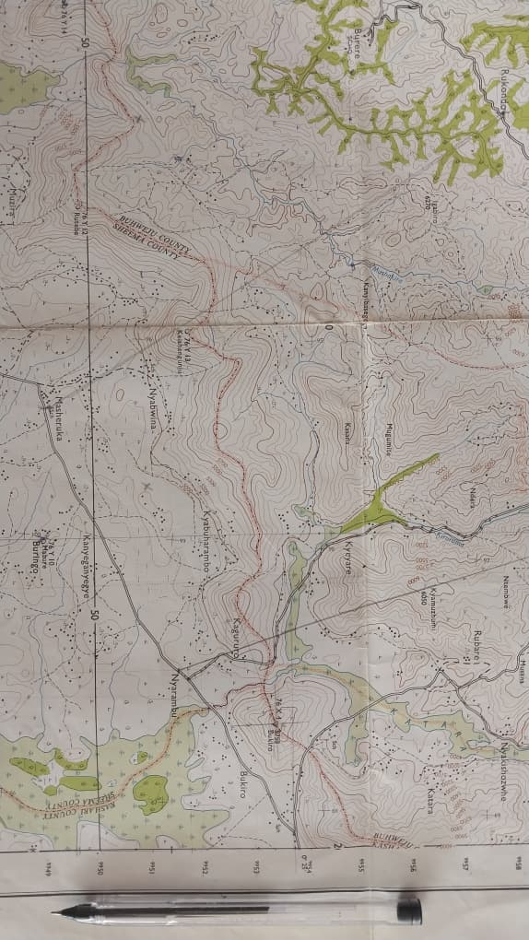

Tasks:
Write a report about the area and in it include:
- A cross section of the area shown on the map between grid references 145550 and 160500; and on it mark and name the relief features, drainage features and land use types.
- Advice, based on the cross section you have drawn, on whether the Local government should go ahead to develop a housing estate on this hill slope or not.
- Possible measures which can be taken to reduce the occurrence of any one natural hazard that can affect the area shown on the map as a result of its relief.

SECTION B
Geomorphic Processes and their Impacts

Part I
Attempt one item from this part.
Item 2: Study the text and Fig.1 below; then do the task that follows.
There is increasing interest among people to understand the world they live in and its e natural resources. Both Science and religion have tried to explain this; yet many still wonder why the world is made up of very large landmasses separated by water bodies. People are also interested in understanding why natural resources are unevenly distributed.
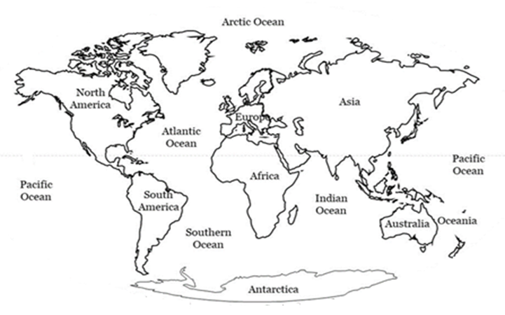
Fig. 1: The World
This search for deeper understanding has led to the development of two groups of people with different ways of thinking. One group believes that the huge landmasses and all the waters separating them were created by God who gathered the waters to create dry land and made all other resources found on the surface, underground, and in the seas. Another group believes that the landmasses and water bodies separating them were formed by natural physical processes that occur within the Earth.
These differing views have attracted the attention of the National Geographical Society (NGS); which is consequently organising a national conference to help people better understand why the world consists of huge land masses separated by large water bodies and how natural resources are related to these features.
As a Geographer, you have been invited by the NGS to make a presentation at the conference.
Task:
Write an essay of about 1,200 words on the subject matter which you will present at the conference.
Item 3: Study the text and Fig.2 below; then do the task that follows.
On 12th March 2025, a strong earthquake with a magnitude of 7.6 on the Richter scale hit the coastal city of Valparaíso, Chile, at 2:37 p.m. local time. The epicentre was 35 km offshore, along the boundary between the Nazca and South American tectonic plates. The tremor lasted for 55 seconds, followed by several strong aftershocks over the next two days.
Although large earthquakes often happen in Chile, smaller ones also occur in East Africa. For example, in July 2019, an earthquake of magnitude 5.0 hit western Uganda, and affected Kasese and Bundibugyo districts.
Because earthquakes happen frequently, some people have different ideas about their causes. Some believe they are caused by angry gods, so they perform sacrifices to calm them. Others believe science can explain earthquakes and help people stay safe from their effects.
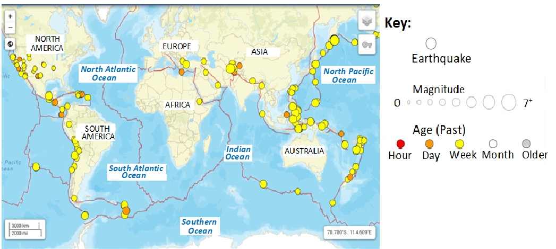
Fig.2: World map showing regions where earthquakes commonly occur
To reduce confusion, the Ministry of Disaster Preparedness and Refugees is planning to publish an article in one of the daily newspapers that will educate people about the science behind earthquakes, their effects and safety measures.
You have been asked, as a geographer, to write the article.
Task:
Write an article which will be published in the newspaper to address the issue.

Part II
Weather and Climate Systems

Attempt one item from this part.
Item 4:
Study the text and Fig 3 below; then do tasks that follow.
You are a Biogeographer studying a remote island ecosystem off the coast of west Africa. The island's climate is unusually mild for its latitude, and the surrounding waters contain a wide variety of fish species, including some that are not typically found in this region.
Recently, local fishermen have noticed changes in the types and distribution of fish they catch, though the cause is unclear. Some people (fisheries officers) believe that these changes are caused by shifts in ocean currents, which may be affecting the temperature and pH of the surrounding waters. Others think that human activities may be responsible for the changes.
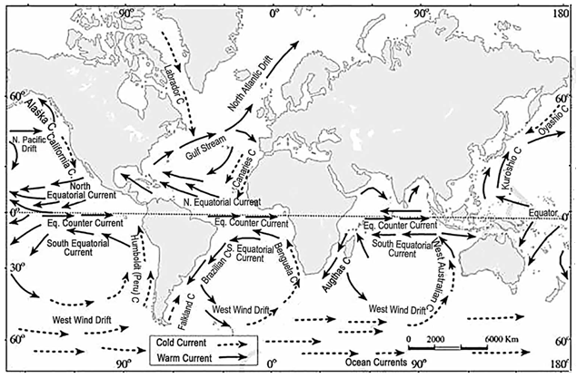
Fig. 3: Ocean currents of the World
You have been tasked with investigating the factors responsible for these conditions.
Tasks:
- Examine the characteristics and causes of the ocean currents affecting this region.

- Analyse the likely effects of these ocean currents on the physical environment and human activities in the adjacent lands?
Item 5:
Study the text and Fig 4 below; then do tasks that follow.
Recent studies in Ghana show that changing weather patterns are seriously affecting key sectors in the country such as agriculture, fisheries, health, and energy. Desertification is advancing at about 20,000 hectares per year, while rising temperatures (projected to increase by 1°C to 3°C by 2050 and 2.3°C to 5.3°C by 2080) threaten crop and fish production. Cocoa and rice yields are expected to fall, hydropower generation is at risk, and water-related diseases such as malaria and cholera are increasing. These impacts worsen poverty and slow national development.
As part of the Africa Continent Climate Action Campaign, the Ghana Meteorological Agency (GMet) has organised a competition for African secondary schools to propose strategies to help Ghana deal with and reduce the effects of changing weather patterns on affected sectors.
You have been selected by the Uganda Ministry of Education and Sports to represent the country in this contest, as a student environmental adviser.
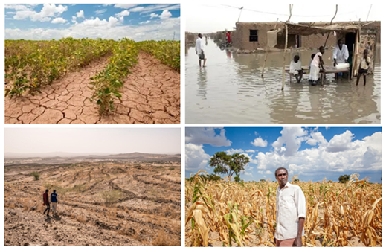
Figure 4: Some of the effects of the changing weather patterns
Tasks:
- Prepare detailed written advice for Ghana which you will present at the conference.
- What challenges do you think Ghana might face in implementing your advice?

END
SCORING RUBRICS FOR P250/1
GEOGRAPHY
PAPER 1
PHYSICAL GEOGRAPHY
RUBRIC FOR ITEM 1

Output | Basis of Assessment | Score 5  Exceptional | Score 4 Outstanding | Score 3 Satisfactory | Score 2  Basic | Score 1  Elementary
Scientific Report containing a cross-section, slope analysis, recommendations, and mitigation measures for a specified natural hazard | Interpretation of Task and Context  Understanding the importance of slope /slope stability in planning and human safety. | Demonstrates a comprehensive understanding of the role as a geomorphologist; clearly explains the relevance of slope analysis to human safety and planning; situates the report effectively within the local government development context. | Demonstrates a clear understanding of purpose and planning context with only minor omissions or limited elaboration. | Demonstrates general awareness of the task and its purpose but with vague reference to context or incomplete framing. | Demonstrates partial understanding; attempts to identify the purpose but misinterprets or oversimplifies the geomorphological task. | Presents a wrong or irrelevant response.
 | Accuracy of the Cross-section;  Precision and correctness in map-based diagram construction. | The cross section is highly accurate and well-labelled cross-section using correct end points, consistent vertical scale, and realistic relief profile; relief, drainage, and land-use features are clearly marked; presentation is neat and in line with principles. | Cross-section is accurate and clearly presented with minor scale or labelling errors; all required features are shown with slight lapses in neatness or proportion. | Cross-section is generally correct but may include some distortions, missing features, or inconsistent scales; labelling is adequate. | Cross-section is partially correct; major errors in plotting, scaling, or labelling reduce accuracy and clarity. | Presents a wrong or irrelevant response.
 | 2.  Generating and Presenting Ideas  Geomorphological Analysis, Reasoning and Advice  Interpretation of slope characteristics and evidence-based decision on housing development. | Demonstrates a thorough, evidence-based analysis of slope form, stability, and related risks; uses evidence from the map cross section logically; offers a clear, justified recommendation supported by geomorphological reasoning. | Presents a sound analysis of slope stability and relief; recommendation is relevant and supported by generally correct reasoning though with minor omissions. | Presents a basic interpretation of slope form and risks; recommendation is reasonable but weakly supported by analysis or limited evidence. | Attempts some analysis but shows limited or confused reasoning; recommendation is vague or inconsistent with evidence. | Presents wrong or irrelevant response.
 | Mitigation and Hazard Management Measures  Feasibility and scientific relevance of proposed measures. | Suggests well-reasoned, and feasible measures to prevent the named hazard risk; measures directly address the identified hazard in respect to slope, climate and drainage conditions. | Suggests appropriate measures with minor gaps in explanation or limited contextual linkage | Suggests some general measures that could reduce hazard risk but are not well linked to the specific area conditions. | Suggests few or unrealistic measures; minimal connection to the hazard context. | Presents a wrong or irrelevant response.
 | 3. Making Informed Judgement  Makes reasoned judgement based on evidence.  Summarises key ideas | Presents a well-reasoned, evidence-based conclusion on whether to develop a housing estate on the slope or not.  Clearly supports decision with geomorphological evidence from the cross-section. | Presents a logical and relevant conclusion, mostly supported by evidence. | Presents a basic conclusion that is relevant but shallow or partly justified. | Presents a vague or weakly reasoned Conclusion, with little connection to slope analysis. | No valid conclusion or judgement.

RUBRIC FOR ITEM 2

Output  Essay on Scientific explanation of why Earth has large landmasses separated by water bodies and how this relates to natural resource distribution | Basis of Assessment | Score 5  Exceptional | Score 4 Outstanding | Score 3 Satisfactory | Score 2  Basic | Score 1  Elementary
 | 1. Interpretation of Task and Context  Understanding the purpose and scope of the scientific essay. | Demonstrates thorough insight into the conference purpose; frames the essay precisely as a scientific explanation; introduction is clear, focused, and coherent. | Demonstrates good understanding of the task and context; framing is relevant and mostly clear. | Demonstrates fair understanding of the task; identifies main idea but with some ambiguity or missing context. | Demonstrates basic understanding of the scientific purpose; introduction is vague, unfocused, or mixes unrelated ideas. | Presenta a wrong or irrelevant response.
 | 2. Generating and Presenting Ideas  Explanation of forces and Mechanism of Separation of continental landmasses  i.e.  Could employ ideas of Seafloor spreading or continental drift. | Presents a well-developed and coherent account of the separation of continental landmasses, and formation of ocean basins; establishing clear links with the internal structure of the Earth and endogenic processes. | Presents a mostly accurate and clear explanation of the separation of continental landmasses and formation of ocean basins, with minor errors / omissions  Linkages to the structure of the Earth may. | Presents a somewhat accurate explanation of the separation of continental landmasses and formation of ocean basins, with noticeable errors / distortions/omissions | Presents a mostly inaccurate explanation of the separation of continental landmasses and formation of ocean basins, with many errors / distortions/omissions | Presents no clear ideas. The response Demonstrates is incoherent, or fails to address the task.
 | Establishment of Relationship Between Evolution of Continents, Landforms and Resource Distribution  Establishment of Linkage between physical processes to the occurrence of resources. | Demonstrates strong analytical linkage between, formation of continents, landforms and resource distribution; reasoning is coherent, evidence-based, and clearly expressed. | Demonstrates reasonable linkage between formation of continents, landforms and resources; examples are relevant though scanty. | Identifies some relationships between landforms and resources; reasoning is simple or partly correct – meets minimum expectation. | Presents few or unclear connections; reasoning is weak or unsupported. | Presents a wrong or irrelevant response.
 | Scientific Reasoning and Judgement.  Integration of ideas into a coherent, evidence-based conclusion. | Builds a logical, well-supported argument with insightful conclusion; demonstrates deep synthesis. | Provides a logical and clear conclusion based on sound evidence, though not fully synthesised. | Provides some reasoning and conclusion, but arguments are simplistic or weakly linked to evidence. | Provides a weak or unclear conclusion; no link evidence or limited reasoning. | Presents a wrong or irrelevant response
 | Making Informed Judgement  Makes reasoned judgement based on evidence.  Summarises key ideas. | Provides a strong conclusion based on evidence.  Clearly links internal geomorphic processes, evolution of contents; and the distribution of natural resources.  Shows critical and logical thinking. | Provides a clear and logical conclusion with some supporting evidence.  Summarises the evolution of continents; and natural resources but with no clear linkage to internal forces and geomorphic processes. | Provides a fair conclusion but with little evidence or reasoning.  Shows some understanding of the evolution of continents; no linkage to internal forces/ and geomorphic processes and natural resources. | Provides a weak or incomplete conclusion.  Limited link to discussion or evidence. | No conclusion or provides one that is wrong or irrelevant to the context and task.

RUBRIC FOR ITEM 3

Output | Basis of Assessment | Score 5 Exceptional | Score 4 Outstanding | Score 3 Satisfactory | Score 2 Basic | Score 1 Elementary
Written article to be published in a newspaper to educate people about earthquakes. | 1. Interpretation of Task / Context  a) Comprehension of the task in relation to the given scenario and context.  b) Relevance and clarity of introduction and background information. | Demonstrates comprehensive understanding of the task and context. Accurately relates the Chile and Uganda scenarios to the global pattern of earthquakes. Provides a clear, engaging, and relevant introduction that captures the purpose of the article and its public awareness role. | Demonstrates good understanding of the task and context. Accurately describes the problem and links it to global or regional patterns, though with minor gaps in depth or clarity. | Demonstrates fair understanding of the task by describing earthquakes generally and mentioning the scenario,  though with noticeable gaps in depth or clarity | Demonstrates limited understanding of the task and context; gives a definition or background with major omissions or unrelated details. Context is vague or poorly connected to the scenario. | Demonstrates little or no understanding of the task or context; response is irrelevant, off-topic, or incoherent.
 | 2. Generating and Presenting Ideas  a) Scientific explanation of the causes of earthquakes (plate tectonics, faulting, subduction, rifting).  b) Use of examples, evidence, or diagrams to illustrate concepts. | Presents a detailed and scientifically accurate explanation of the causes of earthquakes, clearly linking plate movements (e.g., Nazca vs. South American plate, East African Rift) to specific processes such as subduction or crustal faulting. Integrates accurate examples or diagrams/maps effectively. | Presents a largely scientifically accurate and well-structured explanation of causes of earthquake with minor gaps in depth or clarity.  References examples, maps/diagrams but not consistently or with limited elaboration. | Presents a fair or partly correct explanation of causes of earthquakes. May confuse or generalize tectonic processes. Lacks scientific precision or strong links to regional examples.  Uses maps/diagrams occasionally but with noticeable errors or distortions | Presents a weak and inaccurate explanation with unclear or over generalised presentation of tectonic processes  Examples are limited and often not linked to the scenario.  Maps / diagrams are either lacking or grossly faulty | Presents a wrong, irrelevant, or incoherent explanations with no evidence of understanding scientific causes of earthquakes.
 | Examination of Effects of Earthquakes  a) Identification and analysis of social, economic, and environmental effects of earthquakes.  b) Relevance and depth of examples used. | Offers a comprehensive analysis of effects across social, economic, and environmental dimensions. Uses specific examples (e.g., destruction of infrastructure in Chile, displacement of people in Uganda). Explains interconnections and long-term impacts clearly. | Describes major effects accurately, supported by general examples. Some connections between effects and real contexts are made but not in full detail. | Describes common effects such as deaths or damage to infrastructure with brief or general explanations. Examples are minimal or not directly linked to the scenario. | Gives /Lists incomplete or vague effects, focusing on a few aspects without clarity or examples. | Presents irrelevant or inaccurate effects unrelated to earthquakes.
 | Discussion of Safety Measures  a) Range, relevance, and justification of measures suggested.  b) Consideration of practical applicability. | Suggests a wide range of specific, realistic, and context-appropriate measures (e.g., engineering designs, education, early warning, land-use planning). Each is clearly justified in terms of how it reduces risk. | Suggests several relevant measures, mostly appropriate but not fully tailored to Chile/East Africa.  Some justification is given, though lacking clarity and detail in terms of how each measure reduces risk. | Suggests limited or generic measures (e.g., “build strong houses”) with weak or no clear explanations of how each measure reduces risk. | Suggests few or unrealistic measures, showing poor understanding of risk reduction.  Merely lists measures without explanation. | Suggests wrong or irrelevant measures, showing no awareness of disaster preparedness/ reduction.
 | Making Informed Judgement  Makes reasoned judgement based on evidence.  Summarises key ideas. | Provides a strong conclusion based on evidence.  Clearly links occurrence of earthquakes to geological processes and forces.  Summarises effects of earthquakes and safety measures.  Gives opinion about safety measures presented. | Provides a clear and logical conclusion with some supporting evidence.  Mentions effects on both natural and human environments though briefly. | Provides a fair conclusion but with little evidence or reasoning.  Shows some understanding of the science behind earthquakes | Provides a weak or incomplete conclusion.  Limited link to discussion or evidence. | No conclusion or gives one that is wrong or irrelevant to the context and task.

RUBRIC FOR ITEM 4

Output | Basis of Evaluation with Indicators | Score 5  Exceptional | Score 4 Outstanding | Score 3 Satisfactory | Score 2  Basic | Score 1  Elementary
Essay on Characteristics, causes and effects of ocean currents off the West African coast | Interpretation of Task / Context  Shows clear understanding of the scenario/context and task. | Demonstrates comprehensive understanding of the scenario/context and task.  Explains what ocean currents are, identifies the currents off the West African coast and states the intention to discuss their characteristics, causes and effects. | Demonstrates a good understanding of the scenario/context and task  Mentions some of the currents that affect the west African coast and gives a reasonable idea of what the essay is going to discuss. | Demonstrates a fair understanding of the scenario/context and task.  Mentions ocean currents but provides limited context or unclear connection to West Africa.  May not state the purpose of the essay clearly. | Demonstrates limited understanding of the scenario/context and task  Mentions ocean currents vaguely or incorrectly.  Fails to introduce the essay clearly or connect it to the region. | Shows little or no understanding of the task or context; response is irrelevant, off-topic, or incoherent
 | Generating and Presenting Ideas  a) Explains characteristics and causes of the ocean currents clearly.  b) Gives examples and maintains logical flow. | Presents detailed and accurate ideas on both the characteristics and causes of ocean currents.  Logical flow and accurate geographical examples (e.g., the Canaries and Guinea currents).  Ideas are well-connected and clearly explained. | Presents relevant and mostly correct information on the characteristics and causes of ocean currents.  Slight omissions or minor factual errors.  Organization is logical, and examples are given but may lack full/clear explanation. | Presents some relevant ideas but with limited detail or incomplete explanation.  Covers either characteristics or causes better than the other. Some ideas are distorted or loosely organized.  Outlines few or incorrect examples | Lists few and mostly general ideas with little accuracy or detail.  Some ideas may be incorrect or confusing  Lacks clear examples or organization. | Provides little or no relevant content.  Ideas are mostly incorrect or unrelated to the characteristics and causes of ocean currents
 | b) Examines effects of ocean currents on physical environment and human activities  Gives examples and maintains logical flow | Presents comprehensive analysis of how ocean currents influence the Physical environment and Human activities  Gives relevant examples (e.g., Canary and Guinea currents)  Presents ideas logically or coherently. | Presents clear and relevant analysis covering effects on both physical and human environments.  Includes examples but may lack some detail or full linkage.  Presentation is generally logical. | Presents some relevant ideas though with limited depth or few examples.  Organization may be uneven.  Provides an unbalanced view of the effect of ocean currents | Presents few or partly relevant ideas with shallow explanations.  Poor linkage between currents and effects.  Organization is weak/largely incoherent.  Identifies the effect of ocean currents without explanation of causal relationship. | Gives wrong or irrelevant ideas.  Fails to explain effects or connect to ocean currents.  Lacks clear structure or logical flow
 | Making Informed Judgement  Makes reasoned judgement based on evidence.  Summarises key ideas. | Provides a strong conclusion based on evidence.  Clearly links climate conditions, ecological conditions and human activities to ocean currents.  Shows critical and logical thinking. | Provides a clear and logical conclusion with some supporting evidence.  Mentions effects on both natural and human environments though briefly. | Provides a fair conclusion but with little evidence or reasoning.  Shows some understanding of cause-and-effect relationship between ocean currents and physical or human environments | Provides a weak or incomplete conclusion.  Limited link to discussion or evidence. | No conclusion or gives one that is wrong or irrelevant to the context and task.

RUBRIC FOR ITEM 5

Output | Basis of Assessment | Score 5 Exceptional | Score 4 Outstanding | Score 3 Satisfactory | Score 2 Basic | Score 1  Elementary
Written Advice to Ghana on Effects of Climate Change per sector, Strategies to mitigate the effects and the anticipated challenges in doing so | Interpretation of the Scenario / Task  Shows understanding of the scenario/context and task. | Demonstrates deep, accurate, and nuanced understanding of Ghana’s climate-change situation and the contest task. References key data (e.g. desertification, temperature rise, sectors affected) and clearly states the purpose of the advice as a Ugandan student adviser contributing to Ghana’s climate resilience. | Clearly and accurately summarises Ghana’s climate challenges and the advisory task. Mentions major affected sectors and makes a logical link to the student’s role; only minor detail gaps. | Shows fair understanding of the scenario and task. Mentions some relevant impacts or sectors but offers limited detail or weak expression of advisory purpose. | Shows very limited understanding; omits key aspects of Ghana’s situation or misinterprets the task. | Shows no understanding of the scenario; introduction missing or misaligned with scenario.
 |  | Gives a coherent roadmap flowing naturally from the context. Previews all main areas of advice (e.g. agriculture, fisheries, health, energy) and signals that the essay will conclude by discussing likely implementation challenges. | Gives a clear overview outlining main areas of advice and a logical sequence, with brief mention that challenges will also be addressed. | Gives a fair overview that mentions key themes or sectors but omits or vaguely refers to the section on challenges. | Gives a weak or fragmented overview; lists a few areas without logical flow or sense of completeness. | Gives a wrong or irrelevant response.
 | Generating and Presenting Ideas  a).  Explains effects of changing weather patterns on affected sectors.  Shows clear, relevant ideas explaining sector-specific impacts. | Explains effects on all key sectors; demonstrates deep understanding with clear cause-effect links; ideas are insightful and well-articulated | Explains effects on most sectors; demonstrates good understanding; minor gaps in clarity or linkage | Explains effects on some sectors; understanding is fair; cause-effect linkage partial | Explains effects on few sectors; superficial or inaccurate understanding; limited linkage | Ideas irrelevant, incoherent, or absent; presentation fragmented.
 | Proposes realistic, well-linked strategies for reducing or coping with the effects.  Organises information logically and supports ideas with relevant evidence.  Shows clear, relevant ideas proposing strategies; links ideas to effects.  Presents clear, relevant ideas with structure and evidence | Proposes highly realistic, well-linked strategies for all sectors; demonstrates insight, feasibility, and coherence with identified effects.  Ideas are excellently organised; logical flow; fully supported with relevant evidence/examples; persuasive presentation | Proposes mostly realistic and linked strategies for most sectors; minor gaps in feasibility or linkage.  Ideas clearly organised; mostly logical flow; supported with some evidence/examples | Proposes fair strategies; some links to effects; limited feasibility or partial coverage.  Ideas fairly organised; limited logical flow; some evidence/examples | Proposes weak or superficial strategies; few links to effects; largely impractical.  Ideas poorly organised; unclear flow; unsupported or minimal evidence | Strategies irrelevant, incoherent, or absent; presentation fragmented.
 | Analysing and Evaluating Challenges  For each proposed challenge: identifies it, explains why it occurs, describes its effect on implementation; may suggest ways to manage the challenge. | All challenges clearly identified, causes explained, effects/implications fully elaborated, and practical management solutions suggested for most or all. | Challenges identified, causes and effects explained, some management suggestions provided. | Challenges identified, causes or effects explained, but limited detail; no management suggestions. | Some challenges identified but explanations incomplete or unclear; effects mostly missing. | Response is incoherent or off-topic.  Challenges identified are not in line with the topic
 | Practicality  Integrates sector-specific advice and anticipated challenges to make reasoned, practical, and evidence-based recommendations. | Provides a highly coherent, sector-specific synthesis; demonstrates deep understanding of the interplay between strategies and challenges; recommendations are insightful, realistic, well-prioritised, and persuasive. | Provides a clear synthesis linking most sectoral strategies to challenges; recommendations are largely practical and well-reasoned, with minor gaps in detail or prioritisation. | Provides a fair synthesis addressing most sectors; links to challenges are partial; recommendations are generally reasonable but may lack detail or justification. | Provides a weak or fragmented synthesis; sectoral distinctions or links to challenges are limited; recommendations are vague, impractical, or unsupported. | Advice is irrelevant, unfeasible, or absent; conclusion missing or incoherent.  Conclusion on challenges is irrelevant, unfeasible, or absent
 | Making Informed Judgement  Makes reasoned judgement based on evidence.  Summarises key ideas. | Presents a well-reasoned, evidence-based conclusion.  Clearly summarises the recommendations and likely challenges in their implementation. Supports course of action with evidence from the scenario. | Presents a logical and relevant conclusion, mostly supported by evidence. | Presents a basic conclusion that is relevant but shallow or partly justified. | Presents a vague or weakly reasoned Conclusion, with little connection to the scenario/context. | No valid conclusion or judgement.

P250/2
GEOGRAPHY
Paper 2
November/December, 2025
3 hours
Uganda Advanced Certificate of Education
Geography
Paper 2

Human Geography
3 hours

INSTRUCTIONS TO CANDIDATES:
This paper consists of two sections; A and B.
Section A is compulsory
Section B has two parts; I and II. Attempt one item from each part.
Attempt three items in all.
You may use relevant sketch maps, diagrams and statistics, where applicable, to illustrate your answers.
Any additional item(s) attempted will not be scored.
All to the items must be written in the answer booklet(s) provided

ADVICE
- Read the whole test item before answering it-especially if it is made up of more than one part.
- If you finish early, check your answers.

Turn Over
SECTION A

Application of Geographic Tools and Techniques to analysing Human environments

Item 1: Study the text, Tables 1.0 and 1.1; and Fig. 1 below then do the tasks that follow.
Urbanisation in Uganda is growing at a rate of 5.2% per year (National Population Council,2022). This rapid growth puts pressure on the environment, urban facilities, and makes it harder to control and development. Planning is very important because it determines how, when, and where development takes place. However, this is only possible with reliable data on each urban area; data the Ministry of Lands, Housing and Urban Development currently lacks.

To promote orderly growth and improve living conditions, the Ministry has engaged various data collectors, including Advanced Secondary Geography learners.
During a fieldwork study of one of the country’s cities, the learners collected and presented data on land use zones and their characteristics, the proportion of residents in each zone, and the employment status of city residents. Their findings are shown in Tables 1.0, 1.1; and Fig. 1.

The Ministry has requested you, as an Urban Geographer, to analyse this data and recommend ways to improve land use and living conditions in the city.

Table 1.0: Land use zones in the city and their characteristics

Zone & Distance from the Centre (km) | Central Business District (CBD)  (0-1km) | Inner city (2-4 km) | City suburbs (5-6 km) | Urban fringe  (7-9 km)
Land use | Shopping malls, offices, hotels, theatres and entertainment halls | High class housing, Amenity forestry, Leisure parks | Medium class housing, Slum settlements, Squatter settlements, Light manufacturing, Warehousing, Backyard gardening | Low-cost tenement housing, Squatter settlements, Heavy manufacturing, Warehousing, Intensive farming
Nature of buildings | High-rising, Permanent | Multi-storied, Permanent | Bungalows, Tenement houses, Temporary/Makeshift shelter | Bungalows, Tenement houses, Temporary/Makeshift shelter
Density of building | Very high-density building | Medium- density building | High density building | Very high-density building
Amenities | 100% access to piped water, sewerage system, electricity, garbage skips | 100% access to piped water, sewage system, electricity, garbage skips | 40% access to piped water, sewerage system, electricity, garbage skips | 10% access to piped water, sewerage system, electricity, garbage skips
Nature and state of road network | First class tarmac roads, High density, Fair conditions | First class tarmac roads, High density, good conditions | Few tarmac roads, Many bound surface roads and loose surface motorable tracks, Poor state with several potholes | Only main roads are tarmac, Majority are bound surface roads, many loose surface motorable tracks, Poor state with many potholes
Vegetation cover | Scanty and isolated amenity trees, other decorative plants along major avenues | Scattered amenity trees, other decorative compound plants | Very few preserved natural trees, remnants of wetland vegetation | Very few preserved natural trees, remnants of wetland vegetation

Table 1.1: Proportion of residents living in each city zone

ZONE | Population | Percentage of total Population
Central Business District (CBD) | 240,000 | 8.6%
Inner city | 364,000 | 13.1%
City suburbs | 1,120,000 | 43.2%
Urban fringe | 973,000 | 35.1%
Total | 2,773,000 | 100%
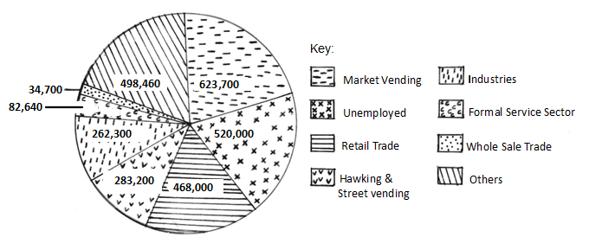
Fig. 1: Employment of City residents by category of work

Tasks:
Use only the information provided in the scenario, tables, and figure to answer the following tasks.
- Determine the Objectives that the team followed while carrying out the study.
- Giving relevant evidence, explain the methods and tools which the team likely used to collect data during the fieldwork study.
- Based on your analysis of the findings, advise the Ministry of Lands, Housing and Urban Development on realistic ways to improve land use and living conditions in the city.

SECTION B: Human- Environment Interaction

Part I

ITEM 2: Study the text, Fig. 2 and Table 2.0 below then do the task that follows.

The African Union has reported that approximately 20% of the population in Sub-Saharan Africa suffers from hunger, with some countries experiencing severe food shortages, as shown in Fig. 2 and Table 2.0. For example, in South Sudan, over 7 million people are facing acute food insecurity. The effects of these shortages are far-reaching with increased malnutrition, reduced economic productivity, and social unrest.

African leaders and food experts still disagree on how to solve the continent’s low farm productivity and ongoing food shortages. Some believe the answer is to use modern, western-style farming methods, while others think increasing the amount of land used for farming is the best solution.

As one of the food production and distribution experts in your country, you have been chosen to attend the 2025 African Food Summit in Addis Ababa, Ethiopia. The theme of the summit is “Addressing low farm productivity in Africa; a sure way of ending food shortages in Sub-Saharan Africa”.

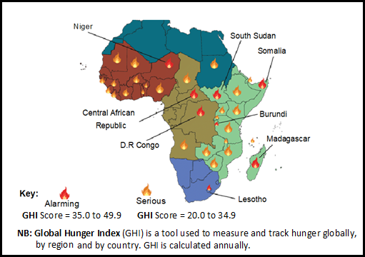
Fig 2: Food crisis in Africa
Table 2.0: Prevalence of Undernourishment in Selected African Countries (2019-2023)

 | 2019 (%) | 2020 (%) | 2021 (%) | 2022 (%) | 2023 (%)
South Sudan | 45.6 | 47.2 | 50.1 | 52.5 | 55.3
Somalia | 38.2 | 40.5 | 42.9 | 45.1 | 47.4
Nigeria | 12.1 | 13.4 | 14.8 | 16.2 | 17.5
Ethiopia | 23.5 | 25.1 | 26.8 | 28.5 | 30.2
DRC | 30.1 | 32.2 | 34.3 | 36.4 | 38.5

Task:
Based on the theme, write a detailed essay which you will present to the African leaders at the summit.

Item 3: Study the text, Table 3.0 and Fig. 3 below then do the tasks that follow.
The world’s population has reached 7.9 billion, with great differences in its distribution, growth and structure, among countries. For example, Japan and Italy are experiencing low fertility rates and ageing populations, while Niger and Somalia have high fertility rates and young populations. These differences in population characteristics greatly affect resource utilisation, development, and environmental sustainability. However, many Least Developed Countries (LDCs) still do not pay enough attention to population issues when planning for development. The relationship between population and development is shown in Table 1.

Table 3.0: Population and Development Indicators for Selected Countries

Country | Population Size (2023) | Population Growth Rate (%) | Human Development Index (HDI) | GDP per capita (USD)
Japan | 123 million | -0.3 | 0.915 | 44,914
Italy | 60 million | -0.1 | 0.895 | 39,637
Niger | 25 million | 3.2 | 0.394 | 601
Somalia | 16 million | 2.9 | 0.361 | 434

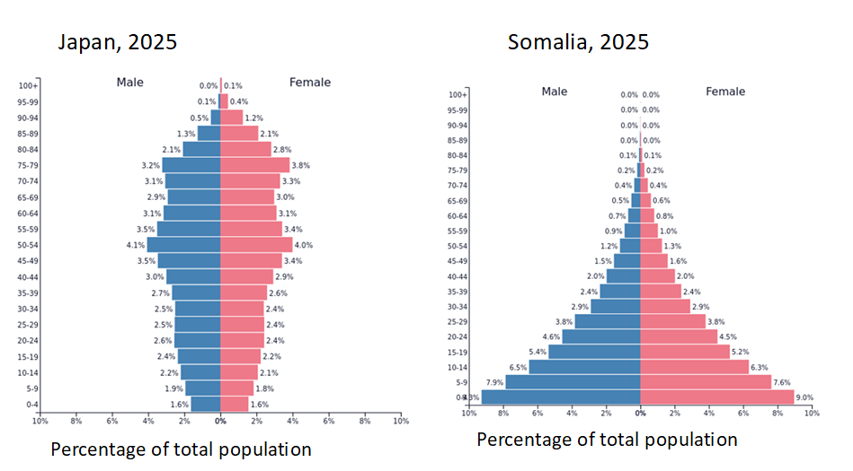
Fig.3: Population structures for Japan and Somalia
Adapted: https://www.populationpyramid.net/spain/2020/

Tasks:
- Using data from Table 1, draw a suitable statistical diagram to show the relationship between population size and GDP per capita for the selected countries.
- Basing on Table 1, account for the great differences in population characteristics between the developed and developing countries.
- Giving evidence from the above scenario and Fig. 2, help Japan and Somalia to understand how their population structures might affect resource utilisation and national development.

Part II
Sustainable Use of Natural Resources
Attempt one item from this part.

Item 4
Study the text and Fig. 4 below then do the tasks that follow.
A rural district in Western Uganda is facing growing pressure on its natural resources including landscape, soils, forests, rivers and wetlands. Over the past years, several areas that were once fertile have become less productive. Meanwhile, the demand for land and energy has increased with population growth. This situation is worrying to several community members who have expressed the need for an immediate solution. The District Environment Committee would like to create awareness in the community on ways of addressing the situation.
The District Environment Committee has requested your school Geography club to help create community awareness about the situation.
As a member of the club’s Environment Awareness Team, you are responsible for preparing materials and giving a short presentation to guide community discussions on how to manage the affected natural resources more sustainably.
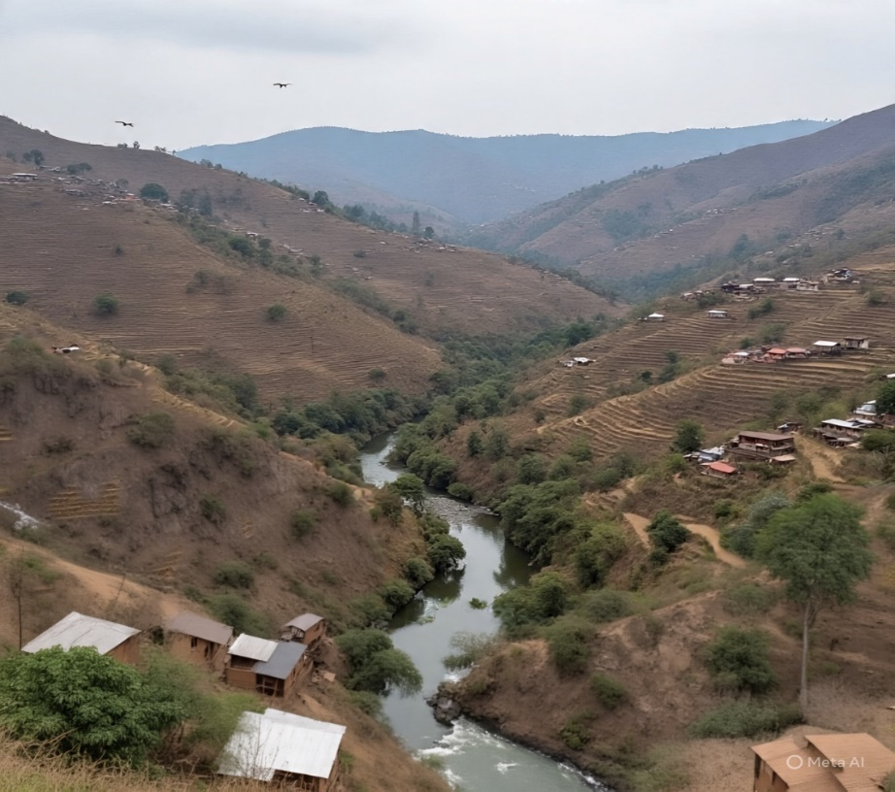
Fig. 4: One of the areas in the rural district

Tasks:
- Using the photograph (Fig. 4), draw a suitable diagram to show the main land use types and areas at risk of environmental degradation.
- Propose ways of utulising the district’s natural resources that are facing a danger of getting degraded sustainably.

Item 5: Study the text and Fig. 5 below then do the tasks that follow.
You are an environmental advisor to the local council in your city. One of the city’s rapidly growing suburbs lies close to a critical wetland that is crossed by a major river feeding into the main drainage system of the country. The wetland is under threat.
In recent months, human activities have increased greatly in the area. A new informal settlement is expanding along the wetland edge, and a private investor wants to build a shopping complex and parking lot within the wetland. At the same time, local residents depend on the wetland for harvesting plant materials, water for domestic and other uses, small-scale vegetable farming, and even disposal of liquid and solid domestic waste.

As a result, the wetland is being degraded, water flow is getting blocked, and the river’s quality is declining. Yet, stopping all human activities would negatively affect people’s livelihoods and economic opportunities. The local council is concerned about this situation and has called a meeting to find a balanced solution that promotes development, community livelihoods and environmental conservation.
You have been invited to present your advice at the meeting.

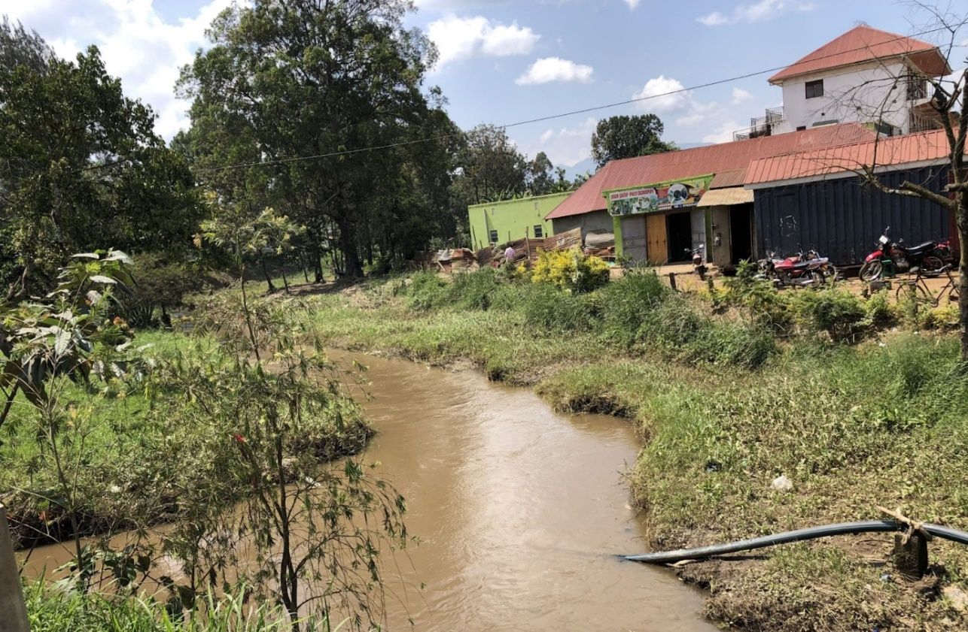

Fig.5: The critical wetland and rapidly growing city suburb
Task:
Assess the situation in the area and propose a plan for sustainable utilisation of resources and development which you will present at the meeting.

End
SCORING RUBRICS FOR P250/2
GEOGRAPHY
PAPER 2
HUMAN GEOGRAPHY

RUBRIC FOR ITEM 1
Output | Basis of Assessment | 5  Exceptional | 4  Outstanding | 3  Satisfactory | 2  Basic | 1  Elementary
a). Written account detailing the Objectives the field study. | Identification of Fieldwork Objectives | States all expected objectives (e.g., land use mapping, housing & population distribution, services/infrastructure assessment), each accurate, clearly worded, and explicitly linked to data (zone names, distances, percentages). No irrelevant aims. | States most objectives (2–3) accurately, with clear wording and good links to findings; one minor omission or slightly general aim. | States some objectives (2 correct) but wording may be partly vague or missing clear data links; may include one partially correct objective. | States few correct objectives (1) with vague wording or weak link to findings; others are irrelevant. | No clear or relevant objectives; statements are too general, unrelated, or incorrect.
b). Written Explanation of the methods used by the team to obtain data during the fieldwork study. | Explanation of Methods and Tools Used during the study | Explains a wide range (≥5) of correct methods and tools, each linked to specific evidence in the tables/figure; shows how each method/tool contributed to the findings. | Explains 4 correct methods/tools with clear links to findings; minor gaps in explaining application or evidence use. | Explains 3 plausible methods/tools with some connection to findings; explanations may be brief. | Mentions 1–2 plausible methods/tools with vague or missing evidence links. | Methods/tools are absent, irrelevant, or not connected to findings.
c). Written Advice to the Ministry of Lands, Housing and Urban Development | Recommendations to Improve Land Use & Living Conditions in the city | Presents comprehensive, realistic, context-specific, and data-justified recommendations covering multiple themes (i.e., social amenities, road network, housing conditions, environment, employment), each clearly linked to findings. | Presents relevant, realistic and mostly practical recommendations with clear data links; may omit one or two of the major themes. | Presents some general recommendations with some data link; coverage of themes is limited. | Presents few vague or unrealistic recommendations with little/no link to findings. | No recommendations provided or those given are irrelevant to the data.
RUBRIC FOR ITEM 2
Output | Basis of Assessment | 5  Exceptional | 4  Outstanding | 3  Satisfactory | 2  Basic | 1  Elementary
A detailed write up to be presented at the African food summit | Understanding of the Problem/context and task | Demonstrates a sophisticated understanding of the problem with precise statistics, clear explanation of severity, and country comparisons. | Demonstrates a thorough understanding of the problem with relevant statistics and explanations; some minor detail gaps. | Demonstrates an adequate understanding of the problem with some correct statistics and explanation but lacking depth. | Demonstrates a limited understanding of the problem; statistics or explanations are weak or incomplete. | Demonstrates minimal or no understanding of the problem; statements are vague, irrelevant, or incorrect.
 | Analysis of Causes | Analyses three causes in depth, each clearly linked to data and country examples; strong cause–effect explanation. | Analyses three causes with clear explanation, minor detail gaps; some links to country data. | Analyses at least two causes with general explanations; few or no links to country data. | Mentions causes but with unclear or weak explanation; no connection to country data. | Causes absent or incorrect; explanations irrelevant.
 | Proposed Solutions | Provides realistic, evidence-based solutions addressing each cause; integrates short- and long-term strategies. | Provides practical solutions addressing each cause; some evidence or examples. | Provides solutions but general, lacking direct links to causes or evidence. | Provides vague or impractical solutions with little connection to causes. | No solutions provided, or solutions irrelevant.

RUBRIC FOR ITEM 3
Output | Basis of Assessment | 5  Exceptional | 4  Outstanding | 3  Satisfactory | 2  Basic | 1  Elementary
a). Statistical diagram illustrating the relationship between population size and GDP per capita of the selected countries. | Presentation of data graphically/diagrammatically | Statistical diagram/Graph is accurate, well-labelled, correctly scaled, and clearly shows relationships for all countries and it is a clear reflection of the data. | Statistical diagram/Graph is accurate and labelled with minor omissions; relationships are well spelt out and easily identifiable. | Statistical diagram/Graph is mostly correct but with some labelling or scaling errors; relationships are inconsistent. | Statistical diagram/Graph is incomplete or unclear; relationships weakly brought out or partially incorrect. | Statistical diagram/Graph missing or incorrect; relationships are absent or misleading.
Written Explanation of causes of variations in population and development between countries | Understanding and explanation of causes of variations in population and development | Provides a comprehensive, accurate, and insightful explanation of causes for all countries; clearly links demographic, economic, social, and political factors; integrates relevant data and examples from the table; response is well-organized, coherent, and clearly written. | Explains most major causes accurately for most countries; links some demographic/economic/social factors; uses some relevant data/examples; response is mostly clear and organized. | Explains some causes accurately for some countries; links to data/examples are limited or superficial; writing is generally understandable but lacks fluency or full coherence. | Gives few or partially correct causes; data/examples used minimally or unclearly; response shows weak organization and clarity. | Provides inaccurate, or irrelevant causes; no meaningful data integration; response is disorganized and unclear.
A write up detailing the implications of population for Japan and Somalia | Explanation of implications of population dynamic for resource utilization and development | Provides a thorough, accurate, and well-linked explanation of implications for both countries; clearly connects population/development variations to resource demand, allocation, and sustainability; integrates data/examples seamlessly; presentation is logical and coherent. | Explains most relevant implications for both countries; links to data/examples present but not fully developed; response is largely clear and coherent. | Explains some implications for one country; data/examples referenced inconsistently; writing is understandable but may lack logical flow. | Gives limited or vague implications; data/examples poorly connected or minimal; organisation and clarity are weak. | Provides inaccurate, or irrelevant implications; no data/examples; response is disorganised and confusing.

RUBRIC FOR ITEM 4

Output | Basis of Assessment | Score 5 | Score 4 | Score 3 | Score 2 | Score 1
A Write up with a diagrammatic Representation of Land Use and Areas at Risk and Proposed Sustainable Utilisation and Management Strategies | Interpretation of Scenario and Understanding of Task | Demonstrates deep understanding of the rural-district context and the sustainability challenge.  Clearly interprets the Geography Club’s advisory role and the purpose of community awareness.  Generates relevant ideas linking population growth, land pressure, and natural-resource degradation. | Demonstrates clear understanding of the situation and the awareness task;  identifies main environmental problems and the need for sustainable management; minor omissions in linkage or detail. | Demonstrates fair understanding of the context;  recognises some problems but with limited insight into sustainability or community-awareness purpose. | Demonstrates limited understanding; refers vaguely to “degradation” or  “awareness” without connecting to resource issues. | Misinterprets or ignores the scenario;  no evidence of understanding of task or context.
 | a) Diagrammatic Representation of Land Use and Areas at Risk of environmental degradation | Presents a well-proportioned, clearly labelled landscape diagram or sketch map accurately showing land-use types (e.g., farmland, forest/vegetation, stream/river, wetland, settlement) and correctly locates and  labels areas at risk of degradation.  Demonstrates spatial understanding, neatness, and clarity suitable for presentation. | The diagram is generally accurate and neatly presented;  shows most of the major land-use types and risk-prone areas; minor lapses in proportion, orientation, or labelling | The diagram is understandable but simplified;  some relevant features shown though placement or labels incomplete; moderate neatness | The diagram weakly represents land use; few or misplaced features;  inaccurate or missing labels; limited neatness | The diagram is absent, irrelevant, or illegible; no meaningful spatial representation
 | Explanation of Environmental Issues and Human Activities | Clearly identifies and explains how specific human activities (farming expansion, deforestation, poor cultivation, wetland reclamation, etc.) are degrading soils, vegetation, and water systems.  Uses cause–effect reasoning and relevant examples from the scenario. | Presents a description of major human activities and their effects accurately; shows understanding of cause–effect relationships though some details or examples missing. | Lists some activities and effects but with limited explanation or weak cause–effect links; few examples | Mentions activities superficially or incorrectly;  little reasoning;  minimal linkage between human action and environmental impact. | No explanation of relevant activities or impacts; response off-topic or confused
 | b) Proposed Sustainable Utilisation and Management Strategies | Presents a comprehensive, realistic set of strategies for sustainable use of soils, forests, wetlands, and water (e.g., agroforestry, contour farming, community tree planting, controlled grazing, energy alternatives).  Links each strategy clearly to the problem it addresses. Shows awareness of social and economic feasibility. | Presents relevant and realistic strategies for most resources;  links to problems mostly clear;  minor gaps in coverage or detail. | Presents fair strategies but generalised or weakly justified;  limited linkage to causes or feasibility considerations. | Presents few or vague strategies;  some unrealistic or poorly linked to identified problems. | Strategies absent, irrelevant, or unfeasible; no demonstration f sustainability thinking.
 | Integration, Judgement and Communication | Integrates key ideas into a logical, evidence-based conclusion showing how sustainable practices can restore productivity and livelihoods.  Demonstrates practical awareness (roles of community, district officials, and students) and ends with a persuasive message suited to community awareness.  Language clear, confident, and organised. | Presents a logical conclusion, summarising main ideas and showing awareness of practical implementation;  communication formal and clear though slightly less persuasive. | Presents a simple concluding statement that restates ideas without strong integration or implementation detail;  language adequate but plain. | Conclusion is weak or poorly linked to body; reasoning is minimal;  communication uneven or informal. | No conclusion or awareness message;  Response is incomplete or incoherent.

RUBRIC FOR ITEM 5

Output | Basis of Assessment | Score 5 | Score 4 | Score 3 | Score 2 | Score 1
Written plan for sustainable utilisation of resources and development in the area. | Interpretation of the Scenario / Task  Shows understanding of the scenario/context and task. | Demonstrates deep, accurate, and scientific understanding of wetlands, their structure and ecological functions (e.g., flood control, water purification, biodiversity support).  Clearly interprets the advisory task and situates it within the context of urban development.  Generates clear and relevant ideas reflecting awareness of environmental and socio-economic dimensions. | Shows clear understanding of wetlands and the advisory task.  Refers to main ecological functions and context of urban growth and community dependence.  Generates logical ideas showing grasp of the environmental issue and the need for balanced advice. | Demonstrates fair understanding of wetlands and the task; gives a general or partial definition.  Shows some awareness of the environmental issue but limited link to the advisory purpose. | Demonstrates limited understanding of wetlands or the task; information vague or partly incorrect.  Presents few relevant ideas; fails to relate to the advisory role. | Misinterprets or omits the scenario; no evidence of understanding of wetlands or task; ideas irrelevant or missing.  Presents a wrong or irrelevant interpretation of the scenario and task.
 |  | Provides a coherent roadmap flowing naturally from the context.  Previews all major discussion areas (human activities, competing needs, sustainable plan and conclusion).  Demonstrates logical flow and relevance between ideas. | Provides a clear overview outlining the main sections of advice in a logical sequence;  briefly signals that the essay will conclude with key recommendations. | Provides a fair overview mentioning some key issues or sections  but lacks full sequence or  connection; overview reads more like a list than a roadmap. | Provides a weak or fragmented overview; only partial or misplaced mention of issues to be discussed;  lacks logical flow or sense of completeness. | Provides no overview or an irrelevant response;  introduction disorganised or missing.
 | Generating and presentation of Ideas  Understanding of Wetlands and their Importance | Demonstrates deep, accurate scientific understanding of wetland structure and ecological functions (e.g., flood control, bio filtration, biodiversity support, carbon storage, livelihood value).  Clearly explains how these roles sustain environmental balance and community wellbeing,  using appropriate examples or evidence. | Demonstrates good understanding of the major functions of wetlands by accurately explaining them; supported with  relevant examples, but with minor lapses in scientific detail or expression. | Demonstrates fair understanding of  several functions of wetlands; gives general but correct explanation of each;  examples are limited or generalised; lacks scientific precision or depth of linkage to wellbeing. | Demonstrates incomplete or partially incorrect understanding of wetlands and their functions; gives  few or unclear examples;  while explanations are vague or superficial. | Demonstrates no accurate understanding;  explanations irrelevant or missing;  major misconceptions about wetlands.
 | Analysing the Situation  Assessment of Human Activities in the wetland and Resulting Impacts | Presents a comprehensive analysis of how settlement, farming, waste disposal and proposed development alter/might alter wetland hydrology, biodiversity, biological functions, water quality and socio-economical value.  Establishes clear cause–effect links supported with evidence or realistic examples.  Ideas are well-organised and logically connected. | Presents a description of major human activities in the wetland and their actual/potential impacts accurately; shows cause–effect understanding with minor omissions or uneven evidence. | Identifies major human activities in the wetland and their actual/potential impacts but explains them generally;  cause–effect links are partial or weak; with limited supporting evidence. | Mentions a few human activities in the wetland with minimal or inaccurate explanation of impacts;  analysis fragmented or repetitive. | Misinterprets or omits activities and impacts;  response is off-topic or incoherent; no analytical reasoning.
 | Logical Flow of Ideas  c) Integration and Evaluation of Competing Needs | Demonstrates deep insight into interdependence among community livelihoods, economic growth and environmental sustainability.  Evaluates conflicts and synergies critically, proposing balanced trade-offs justified by evidence and realistic reasoning. | Shows clear understanding of competing needs;  offers feasible approaches to balance them with some supporting reasoning;  minor gaps in depth or precision. | Recognises that needs conflict but offers descriptive discussion;  evaluation limited, general or lacking evidence;  balance only partially achieved. | Mentions competing interests superficially or one-sidedly;  little attempt to evaluate or reconcile them; reasoning weak. | Ignores or misrepresents competing needs;  no evidence of evaluation or integration.
 | Making Informed Judgement  Proposed Plan for Sustainable Utilisation and Development | Presents a coherent, realistic and scientifically justified plan for sustainable use, restoration and protection of the wetland.  Integrates strategies with earlier analysis and competing needs; uses relevant examples or evidence.  Recommendations are practical, prioritised and persuasive,  communicated in a formal advisory tone suitable for a council presentation. | Presents realistic, well-linked strategies for most key issues; integrates them with prior analysis;  communication generally strong. | Presents fair strategies that address some key issues but with limited justification or weak linkage to analysis;  Communication plain but clear. | Presents few or vague strategies;  weak linkage to issues;  feasibility or coherence doubtful;  communication uneven. | Strategies are absent, irrelevant or unfeasible;  communication disorganised or inappropriate for advisory context.
 | Conclusion/ Judgement / Overall Assessment | Presents a highly informed, insightful, and well-reasoned conclusion;  combines assessment of wetland importance, human impacts, and sustainable measures; demonstrates deep understanding and application of knowledge. | Presents a clear, logical conclusion; supported by evidence; demonstrates sound understanding of wetland issues and sustainability measures. | Presents a generally relevant conclusion; reasoning adequate but lacks depth; limited synthesis of impacts and measures. | Presents a weak conclusion;  reasoning minimal; little synthesis or clarity. | Conclusion unclear, unsupported, or irrelevant; no evident use of knowledge.

Description of Candidates by Construct

Construct 1: Geomorphic Processes and Their Impacts

Analysing the Earth, geomorphic processes and the influence these processes have on human activities using geographic tools and techniques; and proposing feasible ways of coping with, mitigating and adapting to the effects of such processes.
Level | Score Range | Descriptor
Level 5 Exceptional | 26 - 30 | - Demonstrates comprehensive and integrated understanding of geomorphic processes and their relationship with human activities.  - Skilfully uses geographic tools and data to analyse and interpret evidence; and proposes innovative, sound, feasible and context-specific strategies for coping with, mitigating or benefiting from geomorphic effects.
Level 4 Outstanding | 21 - 25 | - Demonstrates clear and well-organised understanding of geomorphic processes and their impacts.  - Applies correct concepts and tools to interpret landscapes and human interactions with them; and provides logical and realistic coping or adaptation strategies for coping with, mitigating or benefiting from geomorphic effects.
Level 3 Satisfactory | 16 - 20 | - Demonstrates adequate understanding of key geomorphic processes and their effects on human activities.  - Uses geographic tools with some accuracy but with limited interpretation or analytical depth; and provides appropriate but conventional coping or adaptation measures lacking clear evidence or contextual detail.
Level 2  Basic | 11 - 15 | - Demonstrates partial or fragmented understanding of geomorphic processes and their impacts.  - Uses geographic tools mechanically or with noticeable errors; and suggests vague, generalised or weakly justified strategies for coping with, mitigating or benefiting from geomorphic effects, with little connection to context.
Level 1 Elementary | 6 - 10 | - Shows minimal or incorrect understanding of geomorphic processes.  - Exhibits glaring misuse or absence of geographic tools; and proposes wrong, unrealistic or no strategies for coping with, mitigating or benefiting from geomorphic effects.

Construct 2: Weather and Climate Systems
Analysing the atmosphere, atmospheric processes and their effects on physical and human environments using a range of geographic tools, techniques, and knowledge to predict short- or long-term weather patterns for places at different scales so as to propose innovative ways of mitigating and adapting to challenges resulting from extreme weather events, climate variability and climate change.

Level | Score Range | Descriptor
Level 5  Exceptional | 26 - 30 | - Demonstrates comprehensive and insightful understanding of the atmosphere, its processes and their effects on environments; supported by accurate use of a wide range of relevant geographic tools and techniques to interpret weather and climatic phenomena; and predicts weather patterns at different scales using scientific evidence.  - Proposes creative, feasible and context-specific strategies for mitigating and adapting to extreme weather events and climate change.
Level 4  Outstanding | 21 - 25 | - Demonstrates clear and accurate understanding of atmospheric processes and their effects on environments; and applies relevant geographic tools competently to analyse and explain observed patterns.  - Provides logical and realistic responses to climate-related challenges with minor inaccuracies.
Level 3  Satisfactory | 16 - 20 | - Demonstrates adequate understanding of major weather atmospheric processes and their effects on environments.  - Uses relevant geographic tools and techniques correctly but with limited analytical detail or interpretation; relates weather events and human activities in general terms, and suggests reasonable but conventional responses to climate-related challenges.
Level 2  Basic | 11 - 15 | - Demonstrates partial understanding of atmospheric processes and their effects on environments.  - Application of relevant geographic tools or techniques is mechanical or incomplete; and suggests responses to climatic challenges are that are simplistic, generalised or weakly linked to evidence or context.
Level 1  Elementary | 6 - 10 | - Shows minimal or inaccurate understanding of the atmosphere, weather and climatic concepts.  - Exhibits little or no use of relevant geographic tools or techniques; and proposes inappropriate, unrealistic or no strategies for mitigation or adaptation to climate-related challenges.

Construct 3: Human – Environmental Interactions
Evaluating development, settlement and production systems at different scales using geographic tools, techniques and relevant knowledge to design effective plans and ways of promoting balanced interaction between people and the environment.

Level | Score Range | Descriptor
Level 5  Exceptional | 26 - 30 | - Demonstrates comprehensive, insightful and integrated understanding of development, population dynamics, settlement systems, and production systems across different scales; and accurately applies relevant geographic tools and techniques to analyse relationships and spatial variations in these aspects.  - Designs, realistic, highly feasible, well-justified, and context-appropriate plans or strategies to address related challenges; and promote balanced sustainable interaction between people and their environment.
Level 4  Outstanding | 21 - 25 | - Demonstrates clear and accurate understanding of development, population dynamics, settlement systems, and production systems supported by competent use of relevant geographic tools and techniques.  - Designs realistic strategies or plans to address identified challenges, with sound justification though with minor lapses in detail or depth.
Level 3  Satisfactory | - - 20 | - Demonstrates adequate understanding of major patterns and issues related to development, population, settlement and production systems; correctly uses relevant geographic tools and techniques but with limited depth or detailed interpretation.  - Proposes reasonable but conventional strategies or plans to address identified challenges; showing limited contextual adaptation or innovation.
Level 2  Basic | 11 - 15 | - Demonstrates partial or inconsistent understanding of issues related to development, population, settlement and production systems; analysis shows gaps, misconceptions, or simplistic interpretation of patterns and trends while use of relevant geographic tools is mechanical or incomplete.  - Proposes strategies or plans to address identified challenges; but are vague, generalised, or weakly linked to evidence or context.
Level 1  Elementary | 6 - 10 | - Shows minimal or inaccurate understanding of issues related to development, population, settlement and production systems; with little or no ability to use relevant geographic tools and techniques.  - Proposes inappropriate, unrealistic, or entirely context-irrelevant strategies or plans to address related challenges.

Construct 4: Sustainable Use of Natural Resources

Designing context-specific and innovative strategies for sustainable utilisation of natural resources, and promotion of environmental stewardship; applying a range of geographical tools and techniques.

Level | Score Range | Description
Level 5  Exceptional | 26 - 30 | - Demonstrates comprehensive and insightful understanding of the nature, distribution, and utilisation of natural resources; and related environmental challenges.  - Accurately uses appropriate geographic tools and techniques to analyse these issues; and proposes innovative, feasible, context-sensitive, precise, coherent, and well-structured strategies for sustainable resource use that reflect environmental stewardship and long-term viability.
Level 4  Outstanding | 21 - 25 | - Demonstrates clear and accurate understanding of natural resources, their utilisation and related sustainability issues.  - Competently applies relevant geographic tools and techniques to interpret patterns, causes, and implications; and provides logical and practical strategies for sustainable resource utilisation, that reflect good awareness of environmental considerations, with minor inaccuracies or limited justification.
Level 3  Satisfactory | 16 - 20 | - Demonstrates adequate understanding of natural resources, their use and basic sustainability principles.  - Uses relevant geographic tools and techniques correctly but with limited analytical depth; and proposes reasonable but conventional strategies to address resource use challenges and sustainability issues with limited contextual detail or innovation.
Level 2  Basic | 11 - 15 | - Demonstrates partial understanding of natural resources and their use or sustainability concerns, with several gaps, generalisations, or misconceptions.  - Use of geographic tools and techniques is incomplete, mechanical, or weakly linked to interpretation; and proposes simplistic, vague, or poorly grounded in evidence or context strategies to address resource use challenges or sustainability issues.
Level 1  Elementary | 6 - 10 | - Demonstrates minimal or inaccurate understanding of natural resources, their use or sustainability concerns, with little or no use of relevant geographic tools and techniques.  - Proposes inappropriate, unrealistic, or entirely context-irrelevant strategies to address resource use challenges or sustainability issues.

