ART AND DESIGN ASSESSMENT GUIDELINES AT ADVANCED SECONDARY LEVEL

1.1 INTRODUCTION
Art and design in the Advanced Secondary Curriculum (ASC) is assessed at school and at the End of the Cycle examinations which is administered by the Uganda National Examinations Board (UNEB).
Assessment of Art and design at school level will be formative and summative. Formative assessment will be done through observation (watching learners working), conversation (asking questions and talking to learners) and appraising the learners’ work (product). While summative assessment will be done through engaging learners in activities of integration at the end of each topic and an examination at the end of the year.
The end of cycle assessment for Art and design for the Advanced Secondary Curriculum will be guided by assessment objectives based on the constructs. A construct is an abstract representation of a unifying theme that brings coherence to an assessment task. It serves as a generalized concept that combines a cluster of related learning competencies—each contributing to a common learning ability. Acquisition of competencies in a construct enables the learner to demonstrate mastery in a way that supports real-life functionality and application.

1.2 ASSESSMENT OBJECTIVES
The end of Cycle assessment for Art and design will be guided by two assessment objectives focusing on the learner’s ability to:
AO1: Analyse artworks that express diverse cultures in order to appreciate production techniques, processes and context so as to gain valuable insights that inform personal judgement.
AO2: Create and present an art product through artistic processes with an intention of communicating a message and/or expressing ideas that solve a contextualized societal problem.

1.3 LINKAGE BETWEEN ASSESSMENT OBJECTIVES, CONSTRUCTS AND SYLLABUS
The table below shows a linkage between the assessment objectives, the constructs and the topics that contribute to the construct.

Table 1: Table showing relationship between assessment objectives, constructs and the topics in the syllabus
Assessment Objective | Construct | Construct Description | Topics in the syllabus
AO1: Analyse artworks that express diverse cultures in order to appreciate production techniques, processes and context so as to gain valuable insights that inform personal judgement. | Art analysis | To make critical analysis of different art forms from various art periods focusing on contexts, artistic expression and communication in order to enhance personal judgement and make informed decisions. | - Appreciation of Classical Antiquity (Greek and Roman art)  4.1b. Influence of Gothic art in Uganda  - Appreciation of the Italian Renaissance Art  - Appreciation of the 19th century art in France and England  - Contemporary Art in Uganda  - Art in Society
AO2: Create and present an art product through artistic processes with an intention of communicating a message and/or expressing ideas that solve a contextualized societal problem. | Artmaking | To Create and present artworks through the production process which effectively communicate messages and, or express ideas for solving a contextualized society problem. | - Objective study of Nature  - Living Person- Body Structure  - Drawing and painting from Imagination  - Drawing and painting from a Living Person  - Drawing and painting from Imagination I  - Adaptations from the Cultural environment  - Drawing and painting from a living person II  - Drawing and painting from imagination II  - The Material Environment  - Living person (Torso)  - Drawing and painting imaginative figurative compositions  - Drawing and painting from a living person (human figure compositions)  - Landscape representation  2.1 Graphic Design Concepts  2.2 Identity Signs and Symbol Design  - Editorial design  - Packaging Design  - Advertising Design  - Design Illustration  - Simulations in Graphics  - Pottery  3.2 Figurative Sculpture in the Round  - Fibre Arts (weaving and basketry)  - Two- dimensional Crafts Phase I  - Two-dimensional and three-dimensional Crafts Phase II  - Portfolio making and art exhibition

2.0 TABLE OF CONSTRUCTS
The table below details the constructs for Art and design. This includes the competencies / learning outcomes that make up the construct, the expected learner abilities and what an assessor should look out for in the learner’s work as evidence of achievement of the intended learning outcomes (indicators of mastery).
Construct | Competency | Ability to | Indicators of masterly | Level of complexity
- Art Analysis  To analyse different art forms from various art periods focusing on contexts, artistic expression and communication in order to enhance personal judgement and make informed decisions. | 4.1a) The learner critically analyses the historical Greek and Roman art in order to compare and assess its adaptation into contemporary art practices in Uganda. | • Interpret Greek and Roman art forms by analysing the use of elements, principles of design, and techniques from specific historical periods. | - Interpretation of context and content of Greek and Roman art forms from observation  - Analysis of specific features of production techniques, processes and characteristics of styles | Medium
 |  | • Explain the adaptation of Greek and Roman art forms in contemporary art in Ugandan practices. | - A written analysis explaining the adaptation of Greek and Roman art forms in Uganda art practices. | Medium
 | 4.1b) The learner analyses the influence of Gothic art on Ugandan art by assessing its artistic value and significance to the present society. | - Interpret Gothic art  - Examine the influence of Gothic art on present artforms in Uganda | - Interpretation of context and content of Gothic Art  - Analysis of the influence of Gothic Art on Art forms in Uganda | Medium
 | 4.2 The learner analyses Renaissance art by investigating its social, cultural and artistic importance for creating own artistic impressions. | • Interpret Renaissance art and examine its influence on contemporary art forms in Uganda.  • Analyse Renaissance art and assess its significance and value on art-making practices in Uganda. | - Analysis of context and content of Renaissance art and its significance to art-making practices in Uganda. | Medium
 | 4.3 The learner evaluates the 19th century art in France and England as a basis to make personal judgement on historical art in relation to Uganda’s contemporary contexts. | • Appraise 19th-century art in France and England as a basis for personal inference and reference in relation to contemporary art in Uganda. | - Evaluation of context and content of 19th-century art in France and England in relation to contemporary art in Uganda. | Medium
 | 4.4 The learner evaluates Ugandan contemporary art practices by examining artists and their artworks to make informed judgement. | • Analyse Ugandan artists and their artworks in terms of their roles and influence on society. | - A written analysis of Ugandan artists; their artworks and influence on society. | Medium
 | 4.5 The learner applies marketing skills of artworks using social, cultural and commercial attributes for survival in society. | • Analyse and make use of marketing strategies based on the social, cultural, and economic attributes of art to survive in society. | - Application of marketing strategies based on research to survive in society. | High

Construct | Topic no. and Competency | Ability to: | Indicators of mastery | Level of complexity
- Art Making  To Create and present artworks through the production process and use of elements and principles of art to communicate messages and, or express ideas for solving a contextualized society problem. | - The learner creates artworks following ideation and planning process by studying the natural environment as an inspiration for art creation.  - The learner draws skeletal and structural images using various materials and tools as a way of demonstrating an understanding of human anatomy.  - The learner interprets textual or oral information along with personal experiences to create drawings and paintings for communication and self-expression. | Develop plans:  - explore the environment or observe the model for inspiration.  - Generate ideas from the environment  - Record experiences or observation  - Organise information  - Reflect on the initial ideas  - Sketch and note down concepts | • Interpreting a context  - Comprehending a contextualised problem  - Generating original ideas  - Reflecting, revising and refining initial concepts into a sketch  - Adopting the initial plans, scaling and transferring the refined sketches  - Using elements and principles, appropriate materials, techniques and technologies  - Finishing and presenting final work | High
 | 1.4 The learner draws or paints different human body parts focusing on their proportions for a true representation of the human structure in artworks.  - The learner creates drawings and paintings using available media and technologies for self-expression and other purposes.  - The learner creates drawings or paintings inspired by the cultural environment using available resources to communicate / convey personal expression about people’s cultures  1.7 The learner draws or paints a human figure proportionally in different poses while exploring with various materials and techniques for effective communication and human figure representation | • Experiment with materials and techniques for drawing or painting the human figure.  • Depict body parts and their correct proportions.  - Portray poses and compositions effectively.  • Take precautions for personal health when handling hazardous materials.  - Maintain a clean and organized working environment.  • imagine, interpret, and reflect on artistic ideas.  • Adapt and adopt elements from the cultural environment to create compositions.  • Experiment, reflect, and revise ideas while drawing or painting.  • Draw or paint using imaginative and creative skills.  - Express oneself and communicate visual ideas and messages using available technologies. |  | High
 | 1.8 The learner draws or paints artworks by applying imaginative skills, through generating and integrating artistic ideas for self-expression and visual communication.  1.9 The learner creates compositions using creative skills, a variety of materials and processes to develop various ideas for art making.  1.10 The learner develops artistic impressions of the human torso using various  materials and tools to communicate human body formations.  1.11 The learner creates figurative imaginative compositions based on the human figure to communicate messages and ideas  1.12 The learner draws and paints human figures in artistic compositions using materials and tools for communication and self-expression.  1.13 The learner creates artworks depicting scenes from different landscapes for communication and self-expression. |  |  | High
 | 2.1 The learner creates graphic designs with type and image by organizing the design principles to achieve effective graphic communication. | - Organize type and image using design principles to create a variety of graphic communications. |  | High
 | 2.2 The learner develops identity signs and symbols using appropriate stages of the creative process for various publication and advertising purposes. |  |  | High
 | 2.3 The learner creates editorial designs using a variety of materials, tools and / or emerging technologies for printing and publication purposes. |  |  | High
 | 2.4 The learner creates package designs using skills and technologies for advertising  various market products. |  |  | High
 | 2.5 The learner creates graphic design concepts using materials and tools suitable for commercial communication |  |  | High
 | 2.6 The learner creates artistic images from a given text using various materials and available technologies to ease and enhance information dissemination. |  |  | High
 | 2.7 The learner develops graphical concepts for simulations using hand or computer aided designing to serve various purposes. |  |  | High
 | 3.1 The learner creates functional earthenware by adapting various forming methods to serve different purposes. | • Produce earthenware design concepts.  • Use various materials, tools, technologies, and forming methods to create functional earthenware.  • Create figurative sculptures in the round for a variety of functions.  • Apply various techniques to produce fiber crafts.  • Provide solutions to artistic problems through project-based work. |  | High
 | 3.2 The learner creates figurative sculptures in the round using various materials, tools and /or emerging technologies for self-expression, economic purposes and a variety of adaptive innovations. |  |  | High
 | 3.3 The learner creates fiber crafts using different techniques and processes to serve various purposes |  |  | High
 | 3.4 The learner produces design concepts using available materials, tools and technologies to decorate different surfaces for various purposes. |  |  | High
 | 3.5 The learner creates craft products based on a chosen theme using suitable materials and technologies to serve different purposes. (Project) |  |  | High
 | 3.6 The learner presents artworks in a portfolio showing the production process for assessment and public viewing. | - Prepare artworks for portfolio presentation (e.g. mount, frame, mat, label, sign, date and number work appropriately)  - Document the creative process as evidence of artistic growth  - Present artworks in an appropriate and professional manner. |  | High

3.0 STRUCTURE OF THE EXAMINATION PAPERS
There will be two examination papers for Art and design at Advanced Secondary Curriculum. A candidate shall be required to sit for paper one (Art analysis) and paper two (Art Making). Paper one examination will be divided into two sections;
Section A focuses on analysis of art from a given historic period while section B requires a critique of contemporary artworks in Uganda. The two sections will form one paper which will be scored at 100%.

Paper 1 Art Analysis will comprise of two sections A and B. Each section will have two items, from which a candidate chooses one. Items in Section A will be set from historic art periods while items from Section B will be derived from Contemporary art. The items in the paper will be scenario-based and the entire paper will take 2 hours.
Paper 2 Art Making will involve creation and presentation of various art forms which communicate intentions and meaning to an audience. The paper will constitute two items from which a candidate selects one. The items in the paper will be scenario-based and the entire paper will be taken within 4hours and 30 minutes. The paper will be divided into two sessions; Session one (Planning) will take 1 hour 30 minutes while session two (Production) will take 3 hours. Session one (Planning) will contribute 30% while session two (Production) will contribute 70% to the final score of 100%.

NB: The candidate will sit for both papers to qualify for the UACE subject grading and certification.

SAMPLE ASSESSMENT PAPERS

Paper One: Art Analysis

Section A: Answer one item only

Item 1:
Scenario
During the Renaissance period, artists were inspired by art works from the classical antiquity, the study of nature and a scientific approach to art. As such, artists created artworks in painting, sculpture and architecture which was systematic and easy to recognize, for example Figure 1. Such artworks are still, appreciated however, contemporary art production in Uganda seem to exhibit a mix of styles and ideas which confuse young artists. Some of these young artists are interested in depicting the legacy of Renaissance art but they don’t know how to go about it.

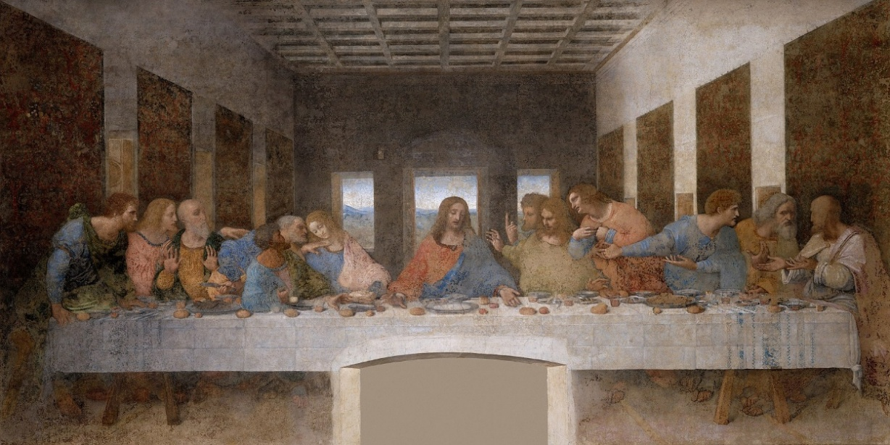
Figure 1 The last supper by Leonardo da Vinci

Task: By analysing the art work in Figure 1, produce a write up of not less than 600 words to advise the young artists on how to address the challenge in the scenario.

Possible aspects:
- Use of proportions
- Perspective
- Chiaroscuro
- Realism (anatomy, disposition of drapery and colour)
- Group compositions
- Figurative painting
- Enhancement of the compositions with architectural structures
- Sfumato approach
- harmony

SAMPLE SCORING RUBRIC FOR ITEM 1

Output | Basis of evaluation with indicators | Level 5  Exceptional | Level 4  outstanding | Level 3  Satisfactory | Level 2  Basic | Level 1  Elementary
Essay of not less than 600 words analysing aspects of Renaissance painting. | - Introduction  A brief interpretation of the context and task (Renaissance painting) | Demonstrates deep understanding of the Renaissance painting. Shows strong awareness of the task’s purpose and its interpretation. | Demonstrates a good understanding of the Renaissance painting. Shows good awareness of the task’s purpose and its interpretation. | Demonstrates a fair understanding of the Renaissance painting. Shows moderate awareness of the task’s purpose and its interpretation. | Demonstrates minimal understanding of the Renaissance painting. Shows minimal awareness of the task’s purpose and its interpretation. | Demonstrates little or no understanding of the Renaissance painting. Shows little or no awareness of the task’s purpose and its interpretation.
 | - Analysis and appreciation  - Explanation of aspects of renaissance painting  (A maximum of six aspects)  - Linkage of the aspects of renaissance painting to the context in the task | Comprehensively explains aspects of Renaissance painting  (6 or more aspects)  Comprehensively links aspects of renaissance painting to the context in the task  (5 or more aspects) | Satisfactorily explains aspects of Renaissance painting  (4 to 5 aspects)  Satisfactorily links aspects of renaissance painting to the context in the task.  (4 aspects) | Moderately explains aspects of Renaissance painting.  (3 aspects)  Moderately links aspects of renaissance painting to the context in the task.  (3 aspects) | Fairly explains aspects of Renaissance painting  (2 aspects)  Fairly links  aspects of renaissance painting to the context in the task.  (2 aspects) | Minimally explains aspects of Renaissance painting.  (1 or none)  Minimally links aspects of renaissance painting to the context in the task.  (1 or none)
 | - Conclusion  A summary of the aspects of Renaissance painting presenting a personal opinion | Presents a well-developed, conclusion that summarises the main aspects of Renaissance painting to form an opinion. | Presents a good conclusion with logical organization, that summarises the main aspects of Renaissance painting to form an opinion. | Presents a general summary of some aspects of Renaissance painting. the Conclusion is relevant but lacks depth or strong synthesis to form an opinion | Presents a conclusion summarizing aspects of Renaissance painting with limited accuracy. Ideas may be incomplete, disorganized, or lack connection to the context | Presents little or no relevant summary of Renaissance painting. May show misunderstanding of key aspects or fail to conclude effectively or completely off-topic.

Item 2:

Scenario
In recent years, many people have observed that Uganda’s contemporary architecture appears plain and lacks the artistic appeal and cultural significance that characterized architectural design styles of the past. This raises concern about the decline of aesthetic and symbolic value in modern Ugandan buildings.
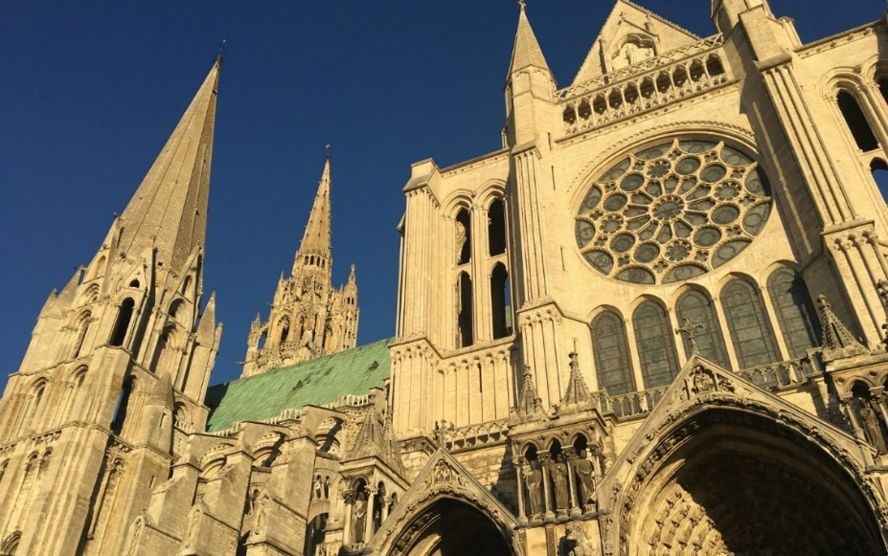
You are an art and design student participating in a national writing competition intended to highlight how global heritage shapes Ugandan architectural design. Your chosen focus is the Chartres Cathedral in France, one of the most remarkable examples of Gothic architecture.
Figure 2. Chartres cathedral France (1194 and 1250)

Task: Write a formal analytical essay (600-800 words) to solve the challenge in the scenario.

SAMPLE SCORING RUBRIC FOR ART ANALYSIS

Output | Basis of evaluation with indicators | Level 5  Exceptional | Level 4  outstanding | Level 3  Satisfactory | Level 2  Basic | Level 1  Elementary
Essay of not more than 600 words with illustrations. | - Interpretation of the context and content  (concepts, vocabulary, themes, iconography and presentation style in a given scenario) | Interpretation of the context and content with all the aspects below: concepts, vocabulary, themes, iconography and presentation style | Interpretation of the context and content with four of the aspects below: concepts, vocabulary, themes, iconography and presentation style | Interpretation of the context and content with three of the aspects below: concepts, vocabulary, themes, iconography and presentation style | Interpretation of the context and content with two of the aspects below: concepts, vocabulary, themes, iconography and presentation style | Interpretation of the context and content with one of the aspects below: concepts, vocabulary, themes, iconography and presentation style
Essay of not more than 600 words with illustrations. | - Analysis and appreciation  Critically evaluates how the effectiveness of specific key features of production techniques, processes and stylistic characteristics used in the work, influences the final outcome and meaning. | Extraordinarily analyses and appreciates how all the production processes, stylistic characteristics,  link the context in the task to the given situation with utmost ease. | Satisfactorily analyses and appreciates how most (80-90%) of the production processes, stylistic characteristics link the context in the task to the given situation with ease. | Moderately analyses and appreciates how some (60-79%) of the production processes, stylistic characteristics link the context in the task to the given situation with relative ease. | Fairly analyses and appreciates how a few (20-59%) of the production processes, stylistic characteristics, link the context in the task to the given situation with some difficulty. | Minimally (5-19%) analyses and appreciates how production processes and stylistic characteristics, link the context of the task to the given situation.
Essay of not more than 600 words with illustrations. | - Expresses personal judgment of historical and socio-cultural influences on the art work and explain their contribution to the development of art in society. | Extraordinarily makes personal judgment of historical and socio-cultural influences on the art work and explains their contribution to the development of art in society. | Satisfactorily makes personal judgment of historical and socio-cultural influences on the art work and explains most (80-90%) of their contribution to the development of art in society. | Moderately makes personal judgment of historical and socio-cultural influences on the art work and explains some (60-79%) of their contribution to the development of art in society. | Fairly makes personal judgment of historical and socio-cultural influences on the art work and explains a few (20-59%) of their contribution to the development of art in society. | Minimally makes personal judgment of historical and socio-cultural influences on the art work and explains no contribution to the development of art in society.
 | - Illustrations in support of the text | NA | NA | NA | Presents illustrations relevant and adequate to the task and context | Presents illustrations detached from the task and context

Section B: Answer one item only

Item 3:

Scenario:
Many people in Uganda visit local art exhibitions and galleries, but they frequently say that such artworks are difficult to understand and therefore they rarely buy. Besides, the contemporary artists who make such art works feel their works are often misinterpreted, as such, their intended messages do not reach the public. Figure 3 is an example of a contemporary painting in Uganda.

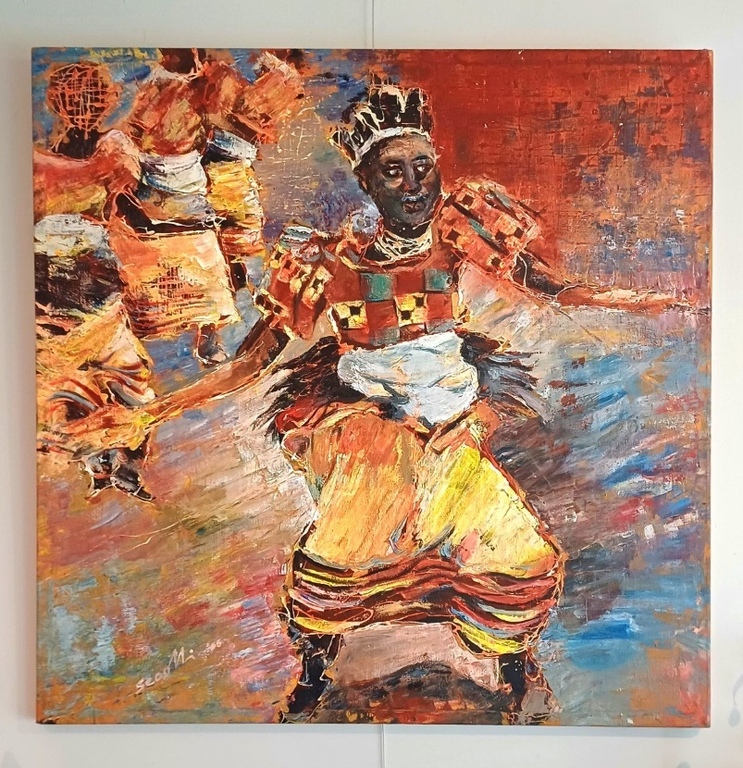
Figure 3: Painting by Colline Sekajugo
Task: Write an assay (600–800 words) advising the contemporary artists on what to capitalize on to address the challenge in the scenario.
Possible aspects:
- Formal analysis; use of elements and principles
- Contextual and historical knowledge; artist’s intention or subject matter
- Cognitive and intellectual connection; interpretation of symbolic meaning
- Content and technique; methods and materials used

SAMPLE SCORING RUBRIC FOR ITEM 1

Output | Basis of evaluation with indicators | Level 5  Exceptional | Level 4  outstanding | Level 3  Satisfactory | Level 2  Basic | Level 1  Elementary
Essay between 600–800 words about making contemporary art interpretable | - Introduction  A brief interpretation of contemporary painting and context of the task. | Demonstrates deep understanding of the contemporary painting. Shows strong awareness of the purpose in the task and its interpretation. | Demonstrates a good understanding of the contemporary painting. Shows good awareness of the purpose in the task and its interpretation | Demonstrates a fair understanding of the contemporary painting. Shows moderate awareness of the purpose in the task and its interpretation. | Demonstrates minimal understanding of the contemporary painting. Shows minimal awareness of the purpose in the task and its interpretation | Demonstrates little or no understanding of the contemporary painting. Shows little or no awareness of the purpose in the task and its interpretation
 | - Analysis and appreciation  - Explanation of aspects of contemporary painting in Uganda  (A maximum of six aspects)  - Linkage of the aspects of contemporary painting in Uganda to the context in the task | Comprehensively explains aspects of contemporary painting in Uganda  (6 or more aspects)  Comprehensively links aspects of contemporary painting in Uganda to the context in the task  (5 or more aspects) | Satisfactorily explains aspects of contemporary painting in Uganda  (4 to 5 aspects)  Satisfactorily links aspects of contemporary painting in Uganda to the context in the task.  (4 aspects) | Moderately explains aspects of contemporary painting in Uganda  (3 aspects)  Moderately links aspects of contemporary painting in Uganda to the context in the task.  (3 aspects) | Fairly explains aspects of contemporary painting in Uganda  (2 aspects)  Fairly links  aspects of contemporary painting in Uganda to the context in the task.  (2 aspects) | Minimally explains aspects of contemporary painting in Uganda  (1 or none)  Minimally links aspects of renaissance painting to the context in the task.  (1 or none)
 | - Conclusion  A presentation of a summary personal interpretation or opinion | Presents a well-developed, conclusion that summarises the main aspects of Renaissance painting to form an opinion. | Presents a good conclusion with logical organization, that summarises the main aspects of Renaissance painting to form an opinion. | Presents a general summary of some aspects of Renaissance painting. the Conclusion is relevant but lacks depth or strong synthesis to form an opinion | Presents a conclusion summarizing aspects of Renaissance painting with limited accuracy. Ideas may be incomplete, disorganized, or lack connection to the context | Presents little or no relevant summary of Renaissance painting. May show misunderstanding of key aspects or fail to conclude effectively or completely off-topic.

Item 4:

Scenario:
Kampala Capital City Authority (KCCA) recently installed one of George William Kyeyune’s contemporary sculptures in a public space, titled “the Stride”. While the work is clearly displayed, many people do not understand it or contemporary sculpture in general. As a result, the sculpture is often underappreciated, and its intended message is lost. You have been asked to help bridge this gap by educating the community about “the Stride” sculpture and its significance in contemporary society.
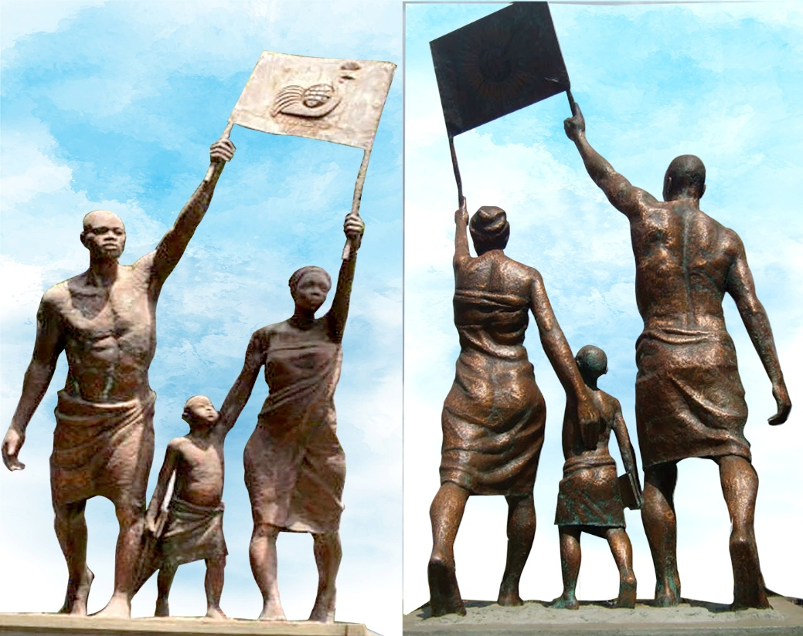
Figure 4. The stride by George Kyeyune (Front and Back views)
Task: Make a write-up of 600–800 words analysing the issues raised in the scenario.

Expected Learning Outcomes:
Competency | Description
Art Analysis | Identifies and explains sculpture’s key visual and stylistic elements.
Interpretation Skills | Understands the theme and message behind Kyeyune’s work.
Cultural Appreciation | Recognizes art’s role in representing and valuing society’s identity.
Communication | Clearly explains artwork to a non-art audience.

SAMPLE SCORING RUBRIC FOR ART ANALYSIS
Output | Basis of evaluation with indicators | Level 5  Exceptional | Level 4  outstanding | Level 3  Satisfactory | Level 2  Basic | Level 1  Elementary
Essay of not more than 600 words with illustrations. | - Interpretation of the context and content  (concepts, vocabulary, themes, iconography and presentation style in a given scenario) | Interpretation of the context and content with all the aspects below: concepts, vocabulary, themes, iconography and presentation style | Interpretation of the context and content with four of the aspects below: concepts, vocabulary, themes, iconography and presentation style | Interpretation of the context and content with three of the aspects below: concepts, vocabulary, themes, iconography and presentation style | Interpretation of the context and content with two of the aspects below: concepts, vocabulary, themes, iconography and presentation style | Interpretation of the context and content with one of the aspects below: concepts, vocabulary, themes, iconography and presentation style
Essay of not more than 600 words with illustrations. | - Analysis and appreciation  Critically evaluates how the effectiveness of specific key features of production techniques, processes and stylistic characteristics used in the work, influences the final outcome and meaning. | Extraordinarily analyses and appreciates how all the production processes, stylistic characteristics,  link the context in the task to the given situation with utmost ease. | Satisfactorily analyses and appreciates how most (80-90%) of the production processes, stylistic characteristics link the context in the task to the given situation with ease. | Moderately analyses and appreciates how some (60-79%) of the production processes, stylistic characteristics link the context in the task to the given situation with relative ease. | Fairly analyses and appreciates how a few (20-59%) of the production processes, stylistic characteristics, link the context in the task to the given situation with some difficulty. | Minimally (5-19%) analyses and appreciates how production processes and stylistic characteristics, link the context of the task to the given situation.
Essay of not more than 600 words with illustrations. | - Expresses personal judgment of historical and socio-cultural influences on the art work and explain their contribution to the development of art in society. | Extraordinarily makes personal judgment of historical and socio-cultural influences on the art work and explains their contribution to the development of art in society. | Satisfactorily makes personal judgment of historical and socio-cultural influences on the art work and explains most (80-90%) of their contribution to the development of art in society. | Moderately makes personal judgment of historical and socio-cultural influences on the art work and explains some (60-79%) of their contribution to the development of art in society. | Fairly makes personal judgment of historical and socio-cultural influences on the art work and explains a few (20-59%) of their contribution to the development of art in society. | Minimally makes personal judgment of historical and socio-cultural influences on the art work and explains no contribution to the development of art in society.
 | - Illustrations in support of the text | NA | NA | NA | Presents illustrations relevant and adequate to the task and context | Presents illustrations detached from the task and context

PAPER 2: ART MAKING

Instruction: Answer only one Item

Either

Item 1
Scenario:
Melani is a community group producing various artworks to generate household income. While the group has been in operation for a while, it is not widely known due to lack of publicity. This has affected their income and customer base. The group is interested in increasing sales in order to improve on the economic and socio-cultural well-being of its members.

Task:
Using the acquired knowledge and skills in art and design, through an appropriate creative process develop a solution to address the challenge presented in the scenario.

PRACTICAL PRODUCTIONS
Output | Basis of evaluation with indicators | Scores 5 | Scores 4 | Scores 3 | Scores 2 | Scores 1
- Poster  - Banner  - Signpost  - Flyer  - Brochure | `  - Ideation (Creative thinking - planning)  - Generation of original ideas /initial sketches based on a given task.  - Develops and refines the initial concepts into final sketches. | Consistently generates several, highly original, innovative ideas into initial sketches that show exceptional creativity and clear relevance to the task.  Skillfully develops and refines initial concepts into polished final sketches following a coherent /systematic process. | Produces several original and creative ideas with minor reliance on common or expected solutions into initial sketches which are clear and purposeful to the task.  Effectively refines initial concepts, showing good attention to detail and improvement between initial and final sketches which are coherent and visually appealing. | Generates some original ideas with familiar or conventional approaches onto initial sketches that show adequate effort and understanding of the task.  Develops concepts with moderate improvement and refinement in final sketches that appear complete but may lack depth or strong visual impact. | Shows limited originality of ideas which are underdeveloped, into initial sketches that demonstrate minimal exploration of the task.  Makes some effort to develop and refine the initial concepts into final sketches but shows little progression from initial work.  Refinement is inconsistent or incomplete. | Rarely generates original ideas into initial sketches that are incomplete, copied, or show minimal or no understanding of the task  Fails to develop or refine initial concepts into final sketches. Final work is incomplete or lacks connection to initial concepts.
 | - Production and presentation  - Transfers the final sketches into the final work using appropriate Materials, tools, techniques and processes.  - Uses elements and principles.  - Presents finished work that serves an intended purpose | Skillfully adopts and adapts the final sketches and effectively uses materials, tools, and techniques with precision while linking the plan and product in response to the task.  Demonstrates outstanding understanding and application of elements and principles (e.g., balance, contrast, unity, proportion).  Produces a high-quality finished art work that clearly meets or exceeds the intended purpose. | Successfully follows the final sketches with minor adjustments where needed and appropriately uses materials, tools and techniques with good craftsmanship.  Applies elements and principles thoughtfully with only minor inconsistencies.  Produces a finished art work that clearly serves its intended purpose and shows good presentation and visual impact. | Adequately converts the initial sketches into the final sketches with some consistency or omissions and uses appropriate materials and tools with uncertainty or inefficiency.  Shows basic use of elements and principles though not always effectively integrated.  Produces fairly finished art work that meets the basic purpose but may lack refinement or strong impact. | Partially transfers sketches with limited adherence to the final sketches and uses limited range of materials, tools and; techniques showing inconsistency or lack of control.  .  Elements and principles are applied superficially or with limited understanding.  Produces an art work that is incomplete or only partially meets intended purpose. | Shows little or no connection between sketches and final work or transfer is incomplete or missing with inappropriate use of materials, tools, and techniques.  Minimal or incorrect application of elements and principles.  Produces an art work that does not meet its intended purpose; unfinished or lacks coherence.

Or

Item 2

Scenario

Culture evolves as people adopt modern ways of living. African culture is rich and reflects human responses to the environment as an integral aspect of life. These rich traditions have evolved over time and are passed down to future generations through verbal expression and practical demonstrations, such as ceremonies and artefacts. The African way of life includes participation in cultural ceremonies, which are rarely represented artistically. This lack of documentation may lead to the gradual loss of cultural information. It has become evident that many ethnic traits are fading away without being recorded in any form. As a result, current and future generations may lack the necessary references to sustain cultural continuity.

Task:

As an art student, use the knowledge and skills gained in art and design, through an appropriate creative process, to produce an original artwork as a solution to the challenge depicted in the scenario.

PRACTICAL PRODUCTIONS
Output | Basis of evaluation with indicators | Scores 5 | Scores 4 | Scores 3 | Scores 2 | Scores 1
- Painting  - drawing  - Collage  - Mosaic  - Batik  - Print making | `  - Ideation (Creative thinking - planning)  - Generation of original ideas /initial sketches based on a given task.  - Develops and refines the initial concepts into final sketches. | Consistently generates several, highly original, innovative ideas into initial sketches that show exceptional creativity and clear relevance to the task.  Skillfully develops and refines initial concepts into polished final sketches following a coherent /systematic process. | Produces several original and creative ideas with minor reliance on common or expected solutions into initial sketches which are clear and purposeful to the task.  Effectively refines initial concepts, showing good attention to detail and improvement between initial and final sketches which are coherent and visually appealing. | Generates some original ideas with familiar or conventional approaches onto initial sketches that show adequate effort and understanding of the task.  Develops concepts with moderate improvement and refinement in final sketches that appear complete but may lack depth or strong visual impact. | Shows limited originality of ideas which are underdeveloped, into initial sketches that demonstrate minimal exploration of the task.  Makes some effort to develop and refine the initial concepts into final sketches but shows little progression from initial work.  Refinement is inconsistent or incomplete. | Rarely generates original ideas into initial sketches that are incomplete, copied, or show minimal or no understanding of the task  Fails to develop or refine initial concepts into final sketches. Final work is incomplete or lacks connection to initial concepts.
 | - Production and presentation  - Transfers the final sketches into the final work using appropriate Materials, tools, techniques and processes.  - Uses elements and principles.  - Presents finished work that serves an intended purpose | Skillfully adopts and adapts the final sketches and effectively uses materials, tools, and techniques with precision while linking the plan and product in response to the task.  Demonstrates outstanding understanding and application of elements and principles (e.g., balance, contrast, unity, proportion).  Produces a high-quality finished art work that clearly meets or exceeds the intended purpose. | Successfully follows the final sketches with minor adjustments where needed and appropriately uses materials, tools and techniques with good craftsmanship.  Applies elements and principles thoughtfully with only minor inconsistencies.  Produces a finished art work that clearly serves its intended purpose and shows good presentation and visual impact. | Adequately converts the initial sketches into the final sketches with some consistency or omissions and uses appropriate materials and tools with uncertainty or inefficiency.  Shows basic use of elements and principles though not always effectively integrated.  Produces fairly finished art work that meets the basic purpose but may lack refinement or strong impact. | Partially transfers sketches with limited adherence to the final sketches and uses limited range of materials, tools and; techniques showing inconsistency or lack of control.  .  Elements and principles are applied superficially or with limited understanding.  Produces an art work that is incomplete or only partially meets intended purpose. | Shows little or no connection between sketches and final work or transfer is incomplete or missing with inappropriate use of materials, tools, and techniques.  Minimal or incorrect application of elements and principles.  Produces an art work that does not meet its intended purpose; unfinished or lacks coherence.

FINAL ART AND DESIGN SUBJECT GRADING
Art and design learning outcomes and competencies have been amalgamated to form the two pillars of: Art Making and Art Analysis. The candidates’ overall performance per construct will be identified and recognised using five letter grades from A to E in a descending order and are meant to differentiate achievement levels as follows;
SUBJECT: Art and Design
CONSTRUCT | CATEGORY | RANGE | DESCRIPTOR
Art Analysis  To analyse different art forms from various art periods focusing on contexts, artistic expression and communication in order to enhance personal judgement and make informed decisions. | Exceptional  A | 18 - 20 | Demonstrates comprehensive and insightful analysis of diverse art forms from various periods by clearly articulating the historical, cultural, and social contexts that influence artistic expressions, communication and makes informed original decisions.
 | Outstanding  B | 15 - 17 | Demonstrates clear understanding of expression and communication in art based on relevant evidence and reasoning and provides thorough and accurate analysis of art forms from different periods by effectively linking context to artistic style and meaning.
 | Satisfactory  C | 12 - 14 | Makes reasonable and generalized judgements with limited supporting evidence while analysing selected art forms, shows some awareness of contextual factors and communicates with basic interpretations.
 | Basic  D | 9 - 11 | Shows limited analysis of art forms with minimal reference to context, expression, or communication. Descriptions may be factual rather than interpretive. Personal judgements are partially informed and lack depth or justification.
 | Elementary  E | 6 - 8 | Provides little or no meaningful analysis of art forms. Fails to recognize contextual influences or artistic expression. Responses are descriptive, fragmented, or inaccurate; personal judgement is unsupported or absent.

CONSTRUCT | CATEGORY | RANGE | DESCRIPTOR
Art Making  To Create and present artworks through the production process and use of elements and principles of art to communicate messages and, or express ideas for solving a contextualized society problem. | Exceptional  A | 26 - 30 | Excellently generates detailed original ideas with convincing evidence of research, produces artwork(s) following all the required creative and presentation processes, displays technique, style and use of technologies and provides an artistic solution to a problem.
 | Outstanding  B | 21 - 25 | Satisfactorily generates original ideas with reasonable evidence of research, produces artwork(s) following most of the required creative processes, displays technique, style and use of technologies and provides an artistic solution to a problem.
 | Satisfactory  C | 16 - 20 | Moderately generates original ideas with evidence of research, produces artwork(s) following some of the required creative processes, displays half hazard use of technique, style and technologies to provide an artistic solution to a problem.
 | Basic  D | 11 - 15 | Fairly generates original ideas with little evidence of research, produces artwork(s) following some few of the required creative processes, displays little use of technique, style and technologies to provide an artistic solution to a problem.
 | Elementary  E | 6 - 10 | Minimally generates ideas with originality and evidence of research, produces artwork(s) following some few of the required creative processes, displays little use of technique, style and technologies with no correlation to a solution to solve a problem in the context.

COMBINED CONSTRUCTS GRADING
SUBJECT | GRADE | RANGE | CATEGORY | DESCRIPTOR
Art & Design | A | 43--50 | Exceptional | Demonstrates comprehensive and insightful analysis of diverse art forms and clearly articulates contexts that influence artistic expressions and makes informed original decisions.
 |  |  |  | Admirably generates detailed original ideas with convincing evidence of research, produces and presents artwork(s) following all the required creative process to provide an artistic solution to a problem.
Art & Design | B | 35--42 | Outstanding | Demonstrates clear understanding of expression and communication in art based on relevant evidence and reasoning by effectively linking context to artistic style and meaning.
 |  |  |  | Satisfactorily generates original ideas with reasonable evidence of research, produces and presents artwork(s) following most of the required creative processes, to provide an artistic solution to a problem.
Art & Design | C | 27--34 | Satisfactory | Makes reasonable and generalized judgements with limited supporting evidence while analysing selected art forms, shows some awareness of contextual factors and communicates with basic interpretations.
 |  |  |  | Moderately generates original ideas with evidence of research, produces and presents artwork(s) following some of the required creative processes, to provide an artistic solution to a problem.
Art & Design | D | 19--26 | Basic | Demonstrates limited analysis of art forms with minimal reference to context, expression, or communication. Descriptions may be factual rather than interpretative. Personal judgements are partially informed and lack depth or justification.
 |  |  |  | Fairly generates original ideas with little evidence of research, produces and presents artwork(s) following some few of the required creative processes, to provide an artistic solution to a problem
Art & Design | E | 12--18 | Elementary | Provides little or no meaningful analysis of art forms. Fails to recognize contextual influences or artistic expression. Responses are descriptive, fragmented, or inaccurate; personal judgement is unsupported or absent.
 |  |  |  | Minimally generates ideas with originality and evidence of research, produces and presents artwork(s) that displays little or no use of the required creative process with no correlation to a solution to solve a problem in the context.

